|  |
| --- |
|  |
| Capstone Project Document |

**Mini Explorer System**

----------------------------------------------------------------

|  |  |  |
| --- | --- | --- |
| **MEx Team** | | |
| **Group Members** | Luyện Bảo Anh | SE03747 |
| Phạm Minh Hoàng | SE03769 |
| Lê Xuân Hướng | SE03388 |
| Phùng Đức Luật | SE03164 |
| Đỗ Cao Phong | SE03196 |
| Đặng Ngọc Tú | SE03591 |
| **Supervisor** | Hoàng Xuân Sơn | |
| **Project code** | MEx | |

**- Hoa Lac, 01/2017 –**

Contents

1. INTRODUCTION 5

**1.1** Purpose 5

**1.2** Acronyms and Definitions 5

**1.3** The People 5

1.3.1 Supervisor 5

1.3.2 Team member 6

**1.4** Project information 6

**1.5** The idea 6

**1.6** Proposal of system 6

1.6.1 The scope 6

1.6.2 Existing system 7

1.8 Benefit from project 8

1.8.1 For team members 8

1.8.2 For community 9

**1.9** Critical assumption and constraints 9

1.9.1 Critical assumption 9

1.9.2 Critical assumption 9

**1.10** Potential risks 9

2. Project management plan 9

3. Requirements 20

3.1.1 User requirement 20

3.1.2 Car requirement 20

3.1.3 Android application requirement 20

3.1.4 Remote Controller requirement 20

3.2.1 Interface requirement 20

3.2.1.1 User Interface 20

3.2.1.2 Hardware interface 21

3.2.1.3 Software interface 21

3.3.2 Functional requirement 25

3.3.2.1 Connect smartphone 25

3.3.2.2 Disconnect Smartphone 26

3.3.2.3. Enter the VR mode 27

3.3.2.4. Enter Controller mode 28

3.3.2.5 Android Speed control 29

3.3.2.6 Android Gear Switch 30

3.3.2.7 Android light signal 31

3.3.2.8 Android Sound signal 32

3.3.2.9 Remote Connect 33

3.3.2.10 Remote Speed control 34

3.3.2.11 Remote Gear Switch 34

3.3.2.12 Remote Light Signal 35

3.3.2.13 Remote Sound Signal 36

3.2.3 Non-Functional Requirement 37

3.2.3.1 Reliability 37

3.2.3.2 Availability 37

3.2.3.3 Maintainability 38

3.2.3.4 Performance 38

3.3.1 Hardware 38

3.3.2 Software and tool 38

4. Research and study 39

4.1 Hardware study 39

4.1.1. Raspberry PI 3 39

4.1.2. Arduino Uno 41

4.1.3. Arduino Wemos-D1R2 42

4.1.4. L298N – Motor module 43

4.1.5. Module XL6009 44

4.1.6. Charging circuit TP4056 44

4.1.7. Gear speed-reducer motor 46

4.1.8. Servo MG996R 47

4.1.10. Camera Logitech C170 48

4.1.11. Module DC-DC Step-Down Voltage converter – MP1584 48

4.2. Software Study 49

4.2.1. Raspi’s Operation system 49

4.2.2. Python 50

5. system design description (sdd) 51

5.1. Architecture design 51

5.2. Sequence diagram 52

5.2. Flowchart 54

6. IMPLEMENTATION & Testing 61

6.1. Proposed system architecture 61

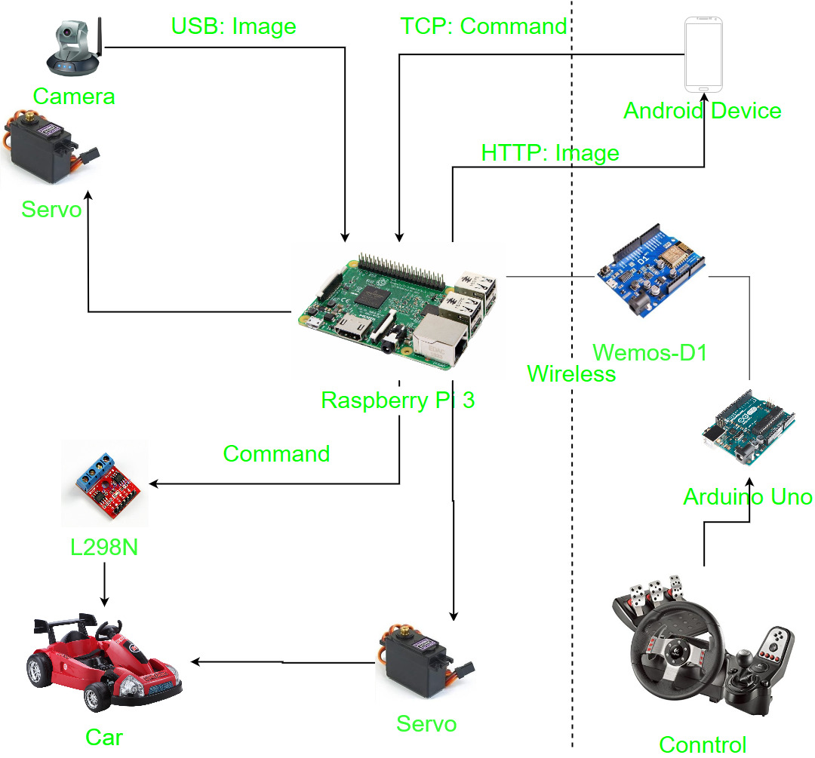 61

6.2. Analysis and selection of tools, devices 61

6.2.1. Motor controller 62

6.2.2. Servo car 63

6.2.3. Servo camera 63

6.2.4. Remote Controller 63

6.2.5. Supply power for car system 64

6.3. Hardware design 64

6.3.1. Raspberry PI connector 64

6.3.2. Remote controller 66

6.4. Software design 67

6.5. Mechanical Design 68

6.6. Testing 71

6.6.1. Purpose 71

6.6.2. Test approach 71

6.6.3. Test environment: 71

6.6.4. Test Case 71

7. Results 75

7.1. Limitation of system 75

7.2. Solution for reducing limitations 76

8. System user’s Manual 76

8.1 Setting up hardware 76

8.2 Android Application 76

8.2.1 Connect WIFI 76

8.2.2 Connect Car system 76

8.2.3 Control car movement 76

8.2.4 VR mode 77

9. References 77

# INTRODUCTION

## Purpose

This document is created as the introduction for project MEx – our Capstone Project at FPT University. In this document, we will descript the overview of some existing systems, the initial idea for our project, a brief description about our expected system and some potential risks, critical assumptions, constrains. Moreover, this document also shows opportunities what it offers for users.

## Acronyms and Definitions

|  |  |
| --- | --- |
| **Acronym & Abbreviation** | **Definition** |
| MEx | Mini Explorer |
| FU | FPT University |
| VR | Virtual Reality |
| Remote Controller | The devices include steering wheel, pedals, gear stitch, used for driving simulator |
| PiCar | The model of automobile, with the Raspberry Pi inside used in this project |

Table

1-1: *Definitions and Acronyms*

## The People

### Supervisor

|  |  |  |  |  |
| --- | --- | --- | --- | --- |
|  | **Full name** | **Phone** | **Email** | **Title** |
| Supervisor | Hoàng Xuân Sơn | 0936232008 | [SonhHX@fe.edu.vn](mailto:SonhHX@fe.edu.vn) |  |

1. Supervisor’s information

### Team member

|  |  |  |  |  |  |
| --- | --- | --- | --- | --- | --- |
| **No** | **Full name** | **StudentID** | **Phone** | **Email** | **Role** |
| 1 | Luyện Bảo Anh | SE03747 | 01672788452 | [anhlbse03747@fpt.edu.vn](mailto:anhlbse03747@fpt.edu.vn) | Team Leader |
| 2 | Phạm Minh Hoàng | SE03769 | 0904882411 | [hoangpmse03769@fpt.edu.vn](mailto:hoangpmse03769@fpt.edu.vn) | Team Member |
| 3 | Lê Xuân Hướng | SE03388 | 01649132648 | [huonglxse03388@fpt.edu.vn](mailto:huonglxse03388@fpt.edu.vn) | Team Member |
| 4 | Phùng Đức Luật | SE03164 | 01656885023 | [luatpdse03164@fpt.edu.vn](mailto:luatpdse03164@fpt.edu.vn) | Team Member |
| 5 | Đỗ Cao Phong | SE03196 | 0979064208 | [phongdcse03196@fpt.edu.vn](mailto:phongdcse03196@fpt.edu.vn) | Team Member |
| 6 | Đặng Ngọc Tú | SE03591 | 0868463132 | [tudnse03591@fpt.edu.vn](mailto:tudnse03591@fpt.edu.vn) | Team Member |

1. Team member information

## Project information

* Project name: Mini Explorer System
* Project code: MEx
* Project group name: MEx Team
* Product type: Embedded System
* Timeline: From May 8th to August 26th, 2017

## The idea

Nowadays, the rapid development of technology has a strong impact on the life of human beings. Along the rapid expansion of economic, the improvement of living standard, the demand of people about a comfort, safe and convenience life, car is going to one of main means of transportation. But in Vietnam, the prices of cars are still too high for people to own one. Therefore, they have to take driving courses so that they can practice in the real car at relatively high prices. Not to mention, during the practice, can cause accidents for the user when they are not proficient yet.

MEx is the idea of first-person view - driving simulation system through virtual reality (VR) technology. The user controls an automobile model by wheel controller, pedals as in the real car. The camera will be set up and provide first-person view to a virtual reality lens to observe all vehicle movements.

The system simulates the whole process of driving a car so that user can learn how to drive easily at home rather than going to the driving courses.

## Proposal of system

### The scope

The scope of MEx is a prototype of control device. It includes both hardware and software. Finally, product must be satisfied some below specification.

* Streaming video with following feature:
  + Frame rate: 24 frames/second.
  + Delay: Depend on network rate.
  + Resolution: 640x480
* Controllers and models must have minimum functions such as running (forward, backward), steering, braking.
* Working on the terrain is relatively flat, not too rough, not too complex, no waves or interference obstructions.
* Tracking the motion of the head to provide the most sensible viewing angle

### Existing system

Recently, there are various products like MEx with good functions, attractive design interface. Below are some of these products:

* + - 1. *FPW Driving – Drive an RC Car with First person view*

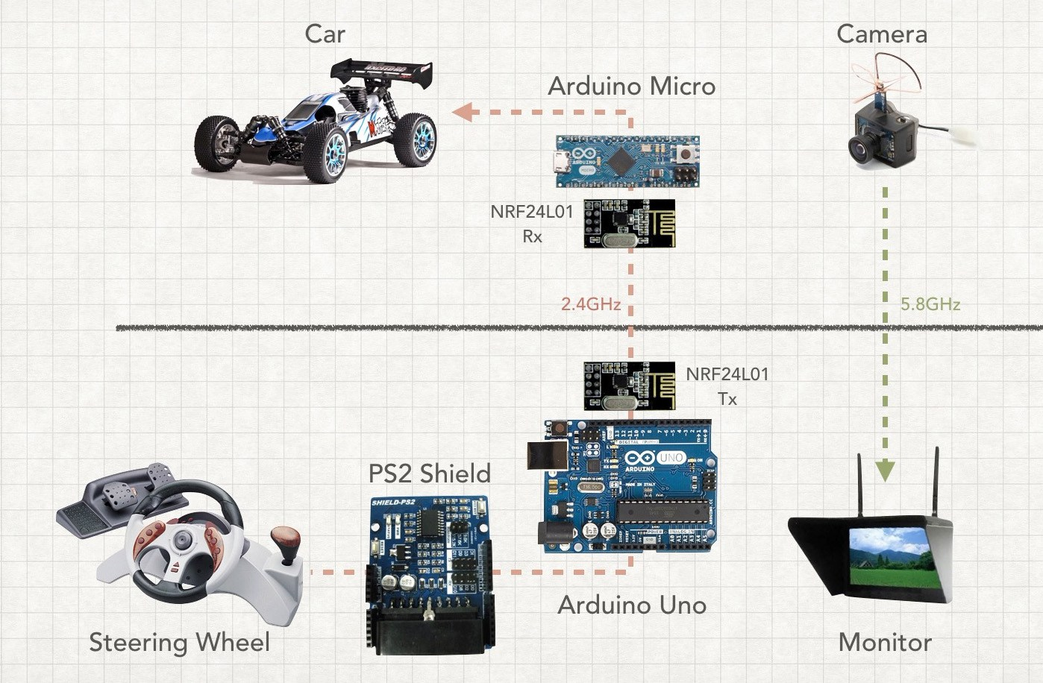 FPW Driving is a prototype of Paul Yan – Arduino Team member. With an old PS2 wheel controller, two Arduinos, a mini FPV camera, and a headset as a standalone monitor, he made a system to control a RC car with first-person view very smoothly. The RC car–which is equipped with a Micro–interfaces with the wheel using an Uno and a PS2 Shield. Both Arduinos communicate via a pair of nRF24L01 modules.

***Figure 1****: FPW-Driving Diagram*

Without tracking the movement of the head, this system can only provide the front sight from straight view of the car. It will become difficult for users when they want to look to the right or left. This is the biggest shortcoming of Yan’s FPW Driving.

* + - 1. *RACEROOM with Oculus Rift*

Raceroom is the one of the most typical driving simulation games. This game offers players a system of more than 20 arcades and more than 60 vehicles to enter the race. With Oculus Rift (VR lens from Microsoft), playing Raceroom will be more fun and realistic with live sound and various gameplay modes.

Player can skip racing mode, and practice driving in a virtual environment. With Driving Force from Logitech or steering wheel from other suppliers, Raceroom would be suitable for those who want to practice driving.

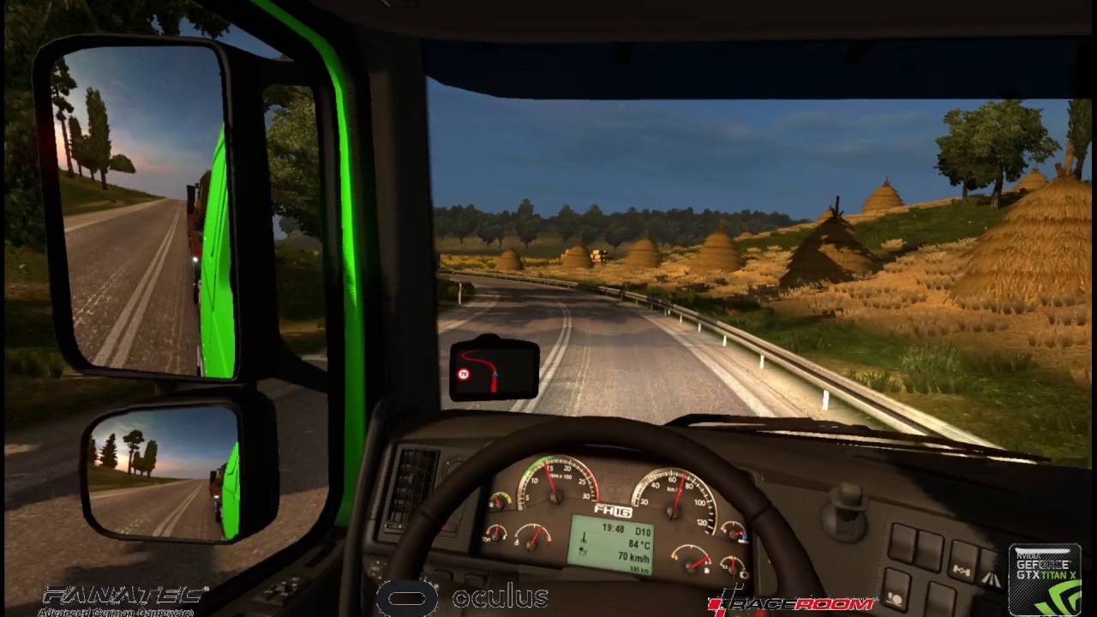***Figure 2:*** *Screen from Playing Raceroom with Oculus Rift*

As a product that has been commercialized, Raceroom is being sold on Steam for around $ 20. Along with the expensive equipment that comes with the Oculus glass, Logitech's controllers make the price of this kit close to $2000. It’s very expensive for drive learner.

## Benefit from project

### For team members

* Have more experiences in working in project, project management.
* Have more knowledge about Arduino, Raspberry Pi, Android and mechanical.
* Improve skill about communicate with team members and how to work in team more effective.

### For community

* Have a new feeling of driving.
* Learn or get more driving practice anytime.
* Explore the distant area without the need for actual movement.

## Critical assumption and constraints

### Critical assumption

* Training: Developers can self-training Arduino and Raspberry Pi Programming with Python in 3 Weeks.
* Human resources: Assume that all members in team have a good healthy to work

### Critical assumption

* Time & Deadline: We must complete task on time. We have 14 weeks for working, each member works 4 hours/day and 5 days/week. We do not have more time for us to complete developing and deliver application to teachers. Besides, we have to submit report documents before deadline to teacher can review.
* Quality: The products must be run well
* Process: We have to follow the software processing of FPT Software
* Human resources: There are 6 members in our team, each member have to study 4 subjects at school.

## Potential risks

After studying about this project, we find out some problem that we may be encountered:

* Under-estimate scope and time or miss deadline because lack of experience in group working, managing and controlling work.
* Equipment got broken because of careless or accident.
* Human resources: Team member cannot complete their works because of health reasons, key member leave team or un-cooperating on team.
* Change requirements: Requirement changed when some functions cannot be completed or some technologies is not suitable.

# Project management plan

**2.1. Definition Problem**

The report 1 is clearly specified reason why MEx project was chose to develop. It is an overview concept about MEx system and be discussed some main function of existing system.

You now have the knowledge of the system’s scope. This document will present project planning to get the target. All the tasks and time to implement, the resource of the system, and the risk maybe meet during development.

***2.1.1. Name of this Capstone Project***

This Capstone project named Mini Explorer System, abbreviated as MEx.

1. ***Boundaries of the System***
2. *Boundaries of the System*

The system under development of this Capstone Project will include:

* The controller has the task of sending the request via wireless, saving control information, controlling device.
* Wireless is an information bridge between the controller and car.
* A central circuit board in the car has responsible for data exchange with the gateway through Arduino to transmit, receive and process information from user.
* User manual, Test Document
* Design circuit broad, Design Document
* Source code Android App and Arduino

*2. Development Environment*

Below is the list of hardware and software requirements needed for development environment:

***Hardware requirements***

o Develop:

* + Arduino/WeMos
  + Raspberry Pi
  + Sensor, servo motor, resistors, capacitors, wire…
  + Personal Computers with 4 Gigabytes of RAM or more
  1. Test:
     + Personal Computers

***Software requirements***

o Operating System: Windows 8.1, 10 Pro – 64bit

o Design software: Proteus 7.8

o IDEs: Android Studio v5.0 and SDK tools, JDK 7, Arduino-1.6.4-windows,Python

o Document: Microsoft Office 2016, Microsoft Project 2016

1. **Project organization**
   1. ***System Process Model***

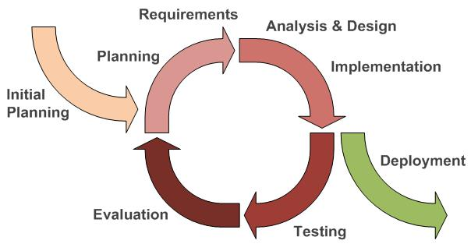

*Figure 2-1: Iterative and Incremental Software Process Model*

This figure above describes the information and products flow lifecycle process model. MEx project uses the Iterative and Incremental Software Process Model.

Iterative and Incremental Software Process Model is a method of software development that is model around a gradual increase in feature additions and a cyclical release and upgrade pattern.

The Iterative and Incremental Software Process Model is most use when the scope of the project is big, the major requirements were defined clearly, some more detail will be added in time, and for the newbie group in software development.

By using this software process model, we break down the developing system task into series of smaller tasks are completed separately, evaluated, and subsequently re-worked until the system’s performance adequately. In addition, the iterative model is easier than other models when the issues were discovery. They are feedback to the team, and solution found while the project is still in development.

1. ***Roles and Responsibilities***
   1. *Organization and Structure*

|  |  |  |  |  |  |  |
| --- | --- | --- | --- | --- | --- | --- |
|  | **Roles** |  |  | **Responsibility** |  |  |
|  |  |  |  |  |  |  |
|  | Project Manager |  |  | Planning developing schedules, allocating resources, keeping | |  |
|  |  |  |  | on schedule, coordinating communication, generally | |  |
|  |  |  |  | responsible for keeping the team’s focus on main goal and tries | |  |
|  |  |  |  | to keep the project team focused on the right goal at a time. | |  |
|  |  |  |  |  | |  |
|  | Technical Leader |  |  | Responsible for the underlying architecture for the hardware |  |  |
|  | (Hardware and Software) |  |  | system and software program, assigning tasks, mentoring |  |  |
|  |  |  | people, reporting. Technical leaders is a reference book for |  |  |
|  |  |  |  |  |  |
|  |  |  |  |  |
|  |  |  |  | other team members. |  |  |
|  |  |  |  |  |  |  |
|  | Quality Assurance Manager |  |  | Ensuring the products meet the certain standards of quality | |  |
|  |  |  |  | from requirements. | |  |
|  |  |  |  |  | |  |
|  | Test Leader |  |  | Responsible for test execution, including test set-up and test |  |  |
|  |  |  |  | run, evaluation of test run and error recovery, defect logging |  |  |
|  |  |  |  |  |
|  |  |  |  |  |
|  |  |  |  | and test results recording. |  |  |
|  |  |  |  |  |  |  |
|  | Developer |  |  | Involve to code product | |  |
|  |  |  |  |  | |  |
|  | Designer |  |  | Involve to design product |  |  |
|  |  |  |  |  |  |  |
|  | Tester |  |  | Involve to test product | |  |
|  |  |  |  |  |  |  |

*Table 2-1: Project Structure*

|  |  |
| --- | --- |
| *2.2.2.2. Project Team Member* | |
|  |  |
|  |  |
| **Team Member** | **Roles** |
|  |  |
| AnhLB | Project Manager, Technical Leader, Developer, Tester |
|  |  |
| HuongLX | Designer, Technical Leader, Developer, Test |
|  |  |
| PhongDC | Technical Leader, Developer, Tester Leader |
|  |  |
| HoangPM | Designer, Developer, Tester |
|  |  |
| LuatPD | Designer, Developer, Tester |
|  |  |
| TuDN | Designer, Developer, Tester |
|  |  |

*Table 2-2: Project Team Member*

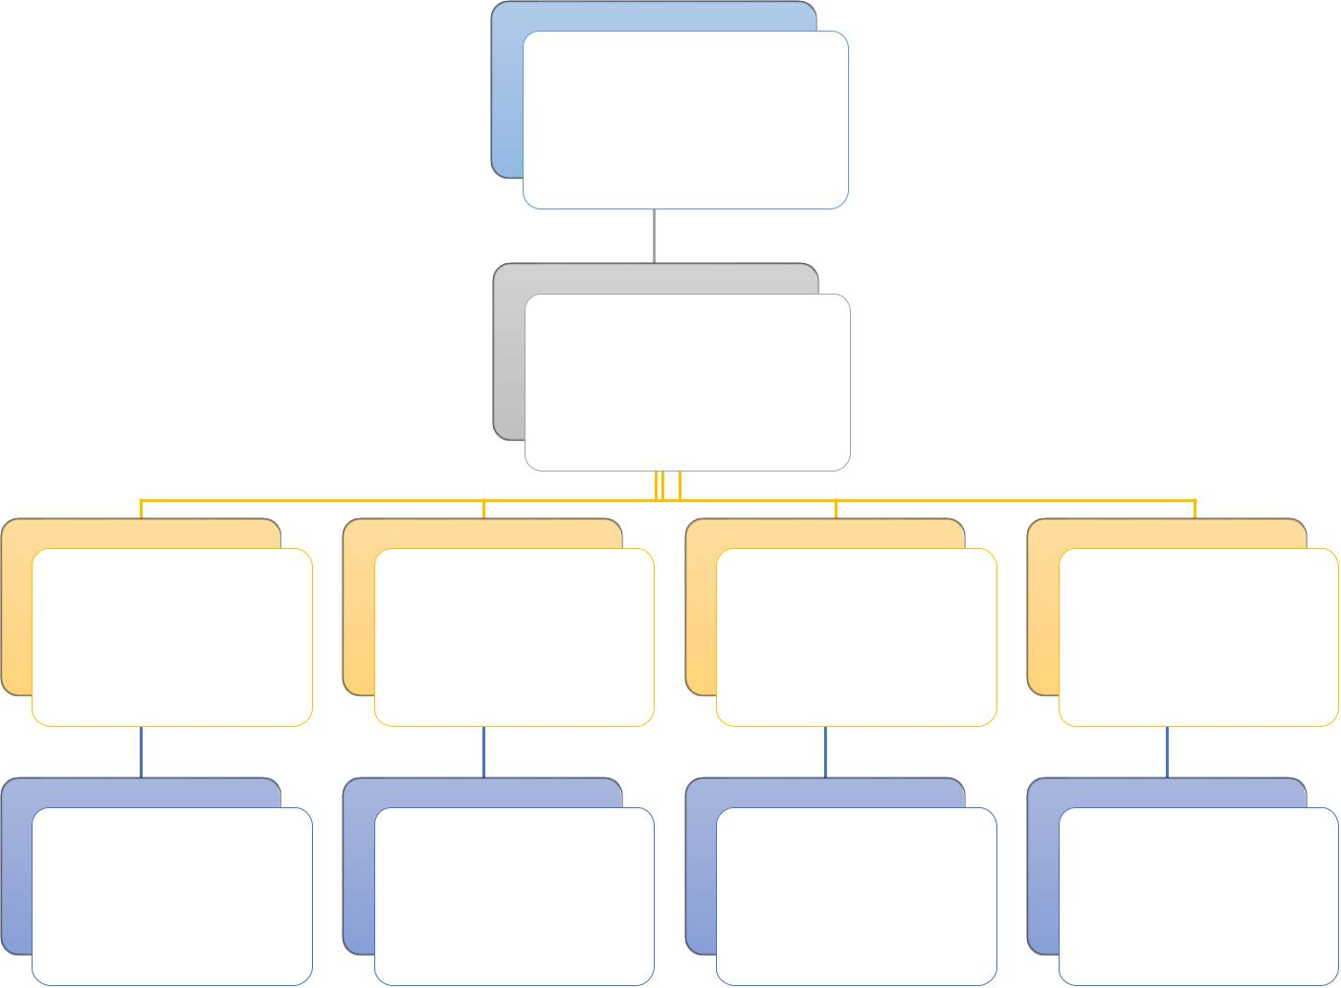SonHX (Supervisor)

AnhLB

(Project Manager)

Technical Designer Developer Testing and QA

|  |  |  |  |  |
| --- | --- | --- | --- | --- |
| - AnhLB | - HoangPM | All of the | All of the |  |
| - HuongLX | - LuatPD |  |
| member | member |  |
| - PhongDC | - TuDN |  |
|  |  |  |

*Figure 2-2: Project Team Member*

***2.2.3. Tools and Techniques***

* Programing languages: Java, Python 3.5, Arduino
* Process Model: Iterative and Incremental Software Process Model.
* IDEs: Android Studio, Arduino IDE, Python IDLE
* Design tool: Fritzing, Photoshop, Proteus
* Other:
  + Revision control: Gitkraken &Tortoise GIT
  + Office tools: MS Office 2016

1. **Project management plan**

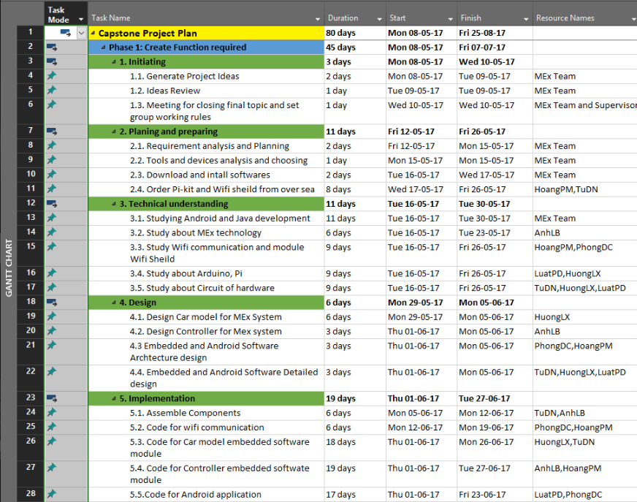

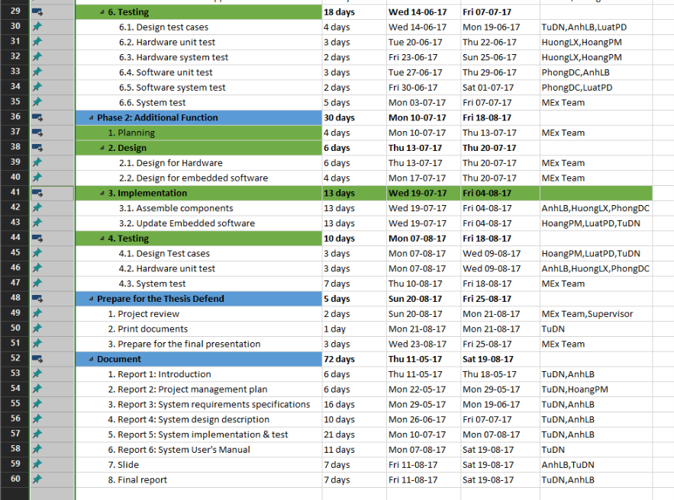

*Figure 2-3: Project Management Plan*

Refer to [MEx_ProjectPlan.mpp]

***2.3.2. Human Resource***

Human resource

* + - Team member
    - Supervisor

Non – human resource

* + Equipment: Personal Computers, Arduino, Raspberry PI
  + Building: FPT University, Thachhoa, Thachthat, Hanoi
  + Building: FPT University’s Library, Thachhoa, Thachthat, Hanoi

***2.3.3. Meeting Minutes***

All meeting minutes will be written follow this template:

|  |  |  |  |  |  |
| --- | --- | --- | --- | --- | --- |
| ***Meeting/Project*** | Mex | |  |  |  |
|  |  |  |  |  |  |
| ***Date of Meeting:*** | *15/5/2017* |  | ***Time: (Type)*** | *2hours* |  |
|  |  |  |  |  |  |
| ***Meeting Called By:*** | *AnhLB* | | ***Location:*** | *FPT University* |  |
|  |  |  |  |  |  |
| ***Note Taker:*** | *TuDN* | | ***Time Keeper:*** | *PhongDC* |  |
|  |  |  |  |  |  |
| 1. Meeting Objective: |  |  |  |  |  |
|  |  |  |  |  |  |
| Brainstorming all functions of systems | | |  |  |  |
|  |  |  |  |  |  |
| 2. Attendance |  |  |  |  |  |
|  |  |  |  |  |  |
| Name | Roles |  | E-mail | Phone |  |
|  |  |  |  |  |  |
|  | Project |  | [@fpt.edu.vn](mailto:Duclqse02946@fpt.edu.vn) |  |  |
|  |  |  |  |  |  |
|  | Tester |  | [@fpt.edu.v](mailto:Tungntse02945@fpt.edu.vn)n |  |  |
|  |  |  |  |  |  |
|  | Developer |  | [@fpt.edu.vn](mailto:Anhpvse02918@fpt.edu.vn) |  |  |
|  |  |  |  |  |  |
| 3. Content: |  |  |  |  |  |
|  |  |  |  |  |  |
|  |  |  |  |  |  |
|  | *Table 2-3: Meeting Minutes Template* | | |  |  |

***2.3.4. Risk Management Plan***

|  |  |  |  |  |  |  |  |  |  |  |  |
| --- | --- | --- | --- | --- | --- | --- | --- | --- | --- | --- | --- |
| **No** | **Name** | **Probability** | |  | **Prevention** |  |  | **Correction** |  | **Impact** |  |
|  |  |  | |  |  |  |  |  |  |  |  |
| 1 | **Miscommunication** | Medium | |  | After a meeting, one |  |  | When it becomes |  | High |  |
|  |  |  | |  | group member |  |  | clear that |  |  |  |
|  |  |  | |  | creates an interview |  |  | miscommunication |  |  |  |
|  |  |  | |  | report. Every |  |  | is causing problem, |  |  |  |
|  |  |  | |  | participant or |  |  | the team members |  |  |  |
|  |  |  | |  | absence person |  |  | are gathered in a |  |  |  |
|  |  |  | |  | should get a copy of |  |  | meeting to clear |  |  |  |
|  |  |  | |  | this report. Team |  |  | thing up. |  |  |  |
|  |  |  | |  | members should not |  |  |  |  |  |  |
|  |  |  | |  | hesitate to ask |  |  |  |  |  |  |
|  |  |  | |  | questions if they are |  |  |  |  |  |  |
|  |  |  | |  | unclear. |  |  |  |  |  |  |
|  |  |  | |  |  |  |  |  |  |  |  |
| 2 | **Design Error** | High | |  | The design should be |  |  | When error in the |  | Medium |  |
|  |  |  | |  | reviewed very |  |  | design are noticed |  |  |  |
|  |  |  | |  |  |  |  |  |  |
|  |  |  | |  | critically. Team leader |  |  | PM or team leader |  |  |  |
|  |  |  | |  | should be consulted |  |  | should be consulted |  |  |  |
|  |  |  | |  | frequency on his |  |  | to help correct the |  |  |  |
|  |  |  | |  | opinion about the |  |  | design errors as soon |  |  |  |
|  |  |  | |  | feasibility and the |  |  | as possible. Also all |  |  |  |
|  |  |  | |  | correctness of certain |  |  | the work, that |  |  |  |
|  |  |  | |  | design decisions. |  |  | depends on the |  |  |  |
|  |  |  | |  |  |  |  | faulty design, should |  |  |  |
|  |  |  | |  |  |  |  | be halted until the |  |  |  |
|  |  |  | |  |  |  |  | error is corrected. |  |  |  |
|  |  |  | |  |  |  |  |  |  |  |  |
| 3 | **Hardware Failure** | Low | |  | Check all of hardware |  |  | Creating a list of |  | High |  |
|  |  |  | |  | before buying. Being |  |  | store that is selling |  |  |  |
|  |  |  | |  | sure and testing about |  |  | this hardware. |  |  |  |
|  |  |  | |  | current and volt of this |  |  | Checking it exist if |  |  |  |
|  |  |  | |  | hardware before |  |  | having plan goes to |  |  |  |
|  |  |  | |  | using. |  |  | buy. |  |  |  |
|  |  |  | |  |  |  |  |  |  |  |  |
| 4 | **Illness or absence** | Medium |  |  | Team members should |  |  | By ensuring that |  | Medium |  |
|  | **of team member** |  |  |  | warn their team leader |  |  | knowledge is shared |  |  |  |
|  |  |  |  |  | timely before a |  |  | between team |  |  |  |
|  |  |  |  |  | planned period of |  |  | members, work can |  |  |  |
|  |  |  |  |  |  |
|  |  |  |  |  | absence. |  |  | be taken over |  |  |  |
|  |  |  |  |  |  |  |  | quickly by someone |  |  |  |
|  |  |  |  |  |  |  |  | else if a person gets |  |  |  |
|  |  |  |  |  |  |  |  | ill. |  |  |  |
|  |  |  |  |  |  |  |  |  |  |  |  |
|  |  |  |  |  |  |  |  |  |  |  |  |
| 5 | **Requirement** | Medium |  |  | Carefully brainstorm |  |  | Team meetings with |  | High |  |
|  | **change** |  |  |  | system’s features |  |  | supervisor to |  |  |  |
|  |  |  |  |  | among team members. |  |  | determine whether |  |  |  |
|  |  |  |  |  | Regularly hold |  |  | new feature should |  |  |  |
|  |  |  |  |  | meeting to define and |  |  | be implemented or |  |  |  |
|  |  |  |  |  | discuss all the features |  |  | not. Team leaders |  |  |  |
|  |  |  |  |  | of systems. Design |  |  | create |  |  |  |
|  |  |  |  |  | system carefully. |  |  | implementation plan |  |  |  |
|  |  |  |  |  | Analyze all the |  |  | for implemented |  |  |  |
|  |  |  |  |  | possible cases to |  |  | features and sent to |  |  |  |
|  |  |  |  |  | minimize the change |  |  | team members. |  |  |  |
|  |  |  |  |  |  |  |  |  |  |  |  |
| 6 | **Time shortage** | High |  |  | Project manager |  |  | Lacking time is the |  | High |  |
|  |  |  |  |  | should create more |  |  | fatal problem, can |  |  |  |
|  |  |  |  |  |  |  |  |  |  |
|  |  |  |  |  | spare time and |  |  | run project to failure. |  |  |  |
|  |  |  |  |  | calculate plus 20% |  |  | PM should analysis |  |  |  |
|  |  |  |  |  | buffer time. |  |  | and has change on |  |  |  |
|  |  |  |  |  |  |  |  | the next phase. |  |  |  |
|  |  |  |  |  |  |  |  |  |  |  |  |

*Table 2-4: Risk Management Plan*

***2.3.5. Communication Plan***

* 1. *Communication between team members*
* *Weekly meeting schedule*: By using Iterative and Incremental Process Model, MExProject System will be divided into a series of small tasks, each task will be assigned to team members by Technical Leader and depend on difficulty, and Technical Leader will be assigned deadlines for each task. We will have a meeting every Thursday, Friday and Monday to report

the progress of whole team’s tasks. Any member who doesn’t finish his/her task (without reasonable explanation), will be fined. If there is any issue, we will discuss and find solution together. If it is too difficult and can’t be solved by ourselves, we will ask our supervisor for advises.

* Unscheduled meeting: If someone has an important problem want to be solved immediately, we will have a meeting for discussion.
* Communication channel: Our main communication channels are face-to-face meeting, email, Facebook, Skype. However, we sometimes can make a phone call or instant message if someone has problem.
  + 1. *Communication with Supervisor*
  + *Face-to-face* meeting: Weekly on every Thursday afternoons to make sure thatsupervisor can keep tracking of the team’s progress.
  + *E-*mail: Gmail is the fastest way to get device and document checking fromsupervisor.
  + *Mobile phone:* is used to get time and place arranged for the meeting every weekly.

1. **Projection Directory**

|  |  |  |
| --- | --- | --- |
| Main folder | Sub-folder | Purpose |
| Document | Design | Diagrams |
| Reports | Store deliverables of reports |
| Plan | Schedule and task list for member |
| Slide | Presentation slideshow and resource |
| Source | Android | Store android app source code |
| Raspi | Store Python code for Raspberry Pi |
| Arduino | Firmware source of Remote Controller |
| Users | Each team members own a folder | Team member’s working area |
| Reference |  | Store reference needed in project |

Table: Project Directory

# Requirements

**3.1. User Requirements Specification**

## 3.1.1 User requirement

* User use smartphone (or remote controller) connect to car’s raspberry pi through WIFI
* User can use smartphone or remote controller to control the movement of the car and the camera
* User can use smartphone to switch control between smartphone or remote controller
* In remote controller mode, user can use smartphone to see the camera view

## Car requirement

* Right direction under the control of user
* Operation of the car must be stable and safe
* Easy to receive signal from user

## Android application requirement

* Well design with minimum cost and maximum quality
* Has long durability in period of time
* Be simple and user-friendly

## Remote Controller requirement

* Auto connect to system
* Low-cost hardware module

**3.2. System Requirement Specification**

## 3.2.1 Interface requirement

### 3.2.1.1 User Interface

User interface (UI) of mobile application must be design base on Flat UI Design. In this project, we only develop mobile application on Android. We ensure that the navigation options in the application will be similar; and all error occurring and exception handling will be catch and display for user with friendly messages.

## 3.2.1.2 Hardware interface

* **Smartphone devices**: the application only runs on smart phone which support Android 4.4+ ; the component helps user to control the car and also display the “view” from the car’s camera
* **Arduino WEMOS**: Use to control the car in remote controller, the signal will be transfer to Raspberry PI through WIFI
* **Raspberry PI**: Receive control signals from remote controller(or Smartphone device) and control the operation motors/Servo; also transfer video data from camera to smartphone device

## 3.2.1.3 Software interface

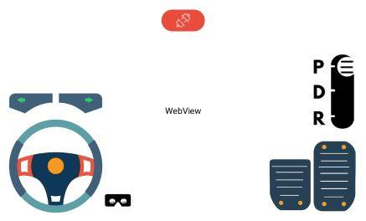

**Figure 3-1: Controller screen**

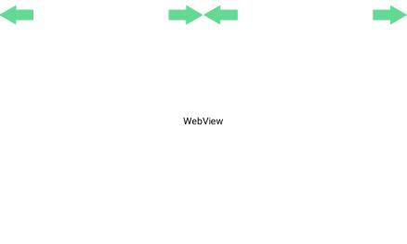

**Figure 3-2: VR mode screen**

This table below will show detail function of all component of **Android application**:

|  |  |  |  |  |
| --- | --- | --- | --- | --- |
| No. | Component | Function | Illustrate Image | Description |
| 1 | Steering Wheel | Control movement of the car |  | User can turn left/right to  Control the car turn left/right |
| 2 | Pedal button | Increase the car speed |  | User can press the button to increase car speed |
| 3 | Break button | Decrease the car speed |  | User can press the button to decrease the car speed |
| 4 | Gear switcher | Switch run mode |  | User can pull the switcher down to change the car mode.  P – parking  D – Forward  R – Backward |
| 5 | Light signal | Light signal |  | User can press an arrow to control car light signal.  Press 1 time to turn on, then press again/or the other button to turn off (or change the light) |
| 6 | Streaming screen | Stream all image info get from camera module in the car |  | Users watch this to know all info that robot’s camera is streaming |
| 7 | VR mode button | Enter the VR mode |  | Press the button to enter the VR mode |
| 8 | Disconnect button | Disconnect to the car system |  | Press the button to disconnect |
| 9 | Light signal | Display the light signal status |  | Receive data from system, when the light signal left/right turn on, the arrow will change into the brighter color |

**Table 3-1: Functions Detail**

**3.3. System Features**

3.3.1 General use Case Diagram

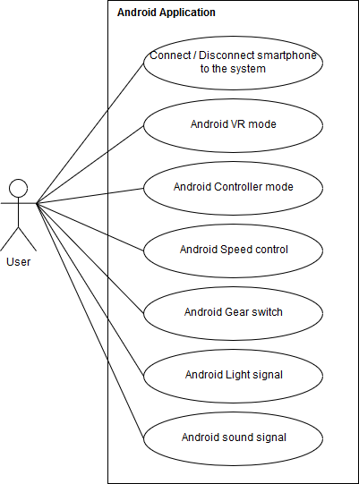

Figure 3-1: Use case (Android) diagram

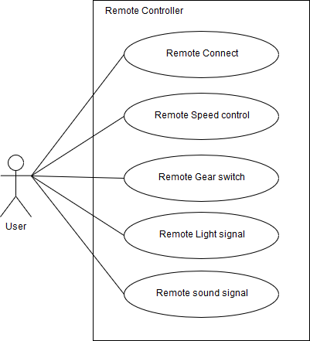

**Figure** 3-2: Use case (Remote controller) diagram

## 3.3.2 Functional requirement

### 3.3.2.1 Connect smartphone

|  |  |  |  |
| --- | --- | --- | --- |
| USE CASE 1 SPECIFICATION | | | |
| Use-case No. | UC001 | **Use-case version** | 1.0 |
| Use-case Name | Connect smartphone | | |
| Author | PhongDC | | |
| Date |  | **Priority** | High |
| Actor: User  Description: User use smartphone to connect to system though WIFI  Goal: Successfully connected to the car system  Triggers:   * Connect to the car WIFI * Start Android Application * Press the “Connect device” button   Pre-condition:   * Android application is start successful * Car WIFI is turn on   Post-condition:   * Disable the Remote controller.   Main Success Scenario:   |  |  |  | | --- | --- | --- | | No | Actor | Action | | 1 | **User** | **Connect to car’s WIFI** | | 2 | **User** | **Press the “Connect device” button** | | 3 | **Car System** | **Check the connection:**   * **Return “OK” if success** * **Return “NO” if fail to connect** * **Return** “**LIMIT” if any device has connected.** | | 4 | **Car System** | **Transfer signal to android device** | | 5 | **Android** | * **If success: move to “controller mode” screen** * **If fail: display message “Could not connect to server, please check the connection”.** |   Alternative Scenario: None  Exceptions: N/A | | | |
|  | | | |

### 3.3.2.2 Disconnect Smartphone

|  |  |  |  |
| --- | --- | --- | --- |
| USE CASE 2 SPECIFICATION | | | |
| Use-case No. | UC002 | **Use-case version** | 1.0 |
| Use-case Name | Disconnect smartphone | | |
| Author | PhongDC | | |
| Date |  | **Priority** | High |
| Actor: User  Description: User use smartphone to disconnect to the car system  Goal: Successfully disconnected to the car system  Triggers:   * Press “disconnect device” button   Pre-condition:   * Android application is connected successful with the car system   Post-condition:   * After disconnect user can connect again.   Main Success Scenario:   |  |  |  | | --- | --- | --- | | No | Actor | Action | | 1 | **User** | **Press “Disconnect device” button** | | 2 | **Android System** | **Display disconnects successful message** | | 3 | **Android System** | **Move to “Main” Screen** |   Alternative Scenario: None  Exceptions: N/A | | | |
| Note and issues: | | | |

### 3.3.2.3. Enter the VR mode

|  |  |  |  |
| --- | --- | --- | --- |
| USE CASE 3 SPECIFICATION | | | |
| Use-case No. | UC003 | **Use-case version** | 1.0 |
| Use-case Name | Android VR mode | | |
| Author | PhongDC | | |
| Date |  | **Priority** | High |
| Actor: User  Description: Allow User to enter VR mode to view the camera in the VR mode and control the car by Remote controller  Goal: Successful enter the VR mode  Triggers:   * Press on “VR mode” button   Pre-condition:   * The Android application is connected successful with the car system * Remote controller is turned on   Post-condition:   * Allow remote controller to control the car * User can turn back to “Controller mode”   Main Success Scenario:   |  |  |  | | --- | --- | --- | | No | Actor | Action | | 1 | **User** | **Press on “VR mode” button** | | 2 | **Android System** | **Send signal to Car system** | | 3 | **Android System** | **Display the “VR mode" screen** |   Alternative Scenario: None  Exceptions: N/A | | | |
| Note and issues: | | | |

### 3.3.2.4. Enter Controller mode

|  |  |  |  |
| --- | --- | --- | --- |
| USE CASE 4 SPECIFICATION | | | |
| Use-case No. | UC004 | **Use-case version** | 1.0 |
| Use-case Name | Controller mode | | |
| Author | PhongDC | | |
| Date |  | **Priority** | High |
| Actor: User  Description: Allow User to enter Controller mode to control the car by Android application  Goal: Successful enter the Controller mode  Triggers:   * Press on “back” button on the Android device   Pre-condition:   * Successful enter the “VR mode”   Post-condition:   * The remote controller is disable. * User can turn back to the “VR mode”   Main Success Scenario:   |  |  |  | | --- | --- | --- | | No | Actor | Action | | 1 | **User** | **Press on “back” button** | | 2 | **Android System** | **Send signal to the car system** | | 3 | **Car System** | **Disable the “Remote controller”** | | 4 | **Android System** | **Display the “Controller mode” screen** |   Alternative Scenario: None  Exceptions: N/A | | | |
| Note and issues: | | | |

### 3.3.2.5 Android Speed control

|  |  |  |  |
| --- | --- | --- | --- |
| USE CASE 5 SPECIFICATION | | | |
| Use-case No. | UC005 | **Use-case version** | 1.0 |
| Use-case Name | Android speed control | | |
| Author | PhongDC | | |
| Date |  | **Priority** | High |
| Actor: User  Description: Use Android application to control the car movement  Goal: Control movement of the car  Triggers:   * Turn the steering wheel to left or right that user want the car to turn in that direction. * Press the “Pedal” button to increase the movement speed of the car * Press the “break” button to decrease the movement speed of the car   Pre-condition:   * Android application is connected successful with the car system * Enter the “Controller mode” * Gear switch isn’t in “parking mode”   Post-condition:   * N/A   Main Success Scenario:   |  |  |  | | --- | --- | --- | | No | Actor | Action | | 1 | **User** | **Turn the steering wheel to left or right and also press the “Pedal” button to increase the movement speed or press the “break” button to decrease the movement** | | 2 | **System** | **Send a signal to car’s system to control the movement of the car** |   Alternative Scenario: None  Exceptions: N/A | | | |
| Note and issues: | | | |

### 3.3.2.6 Android Gear Switch

|  |  |  |  |
| --- | --- | --- | --- |
| USE CASE 6 SPECIFICATION | | | |
| Use-case No. | UC006 | **Use-case version** | 1.0 |
| Use-case Name | Android Gear switch | | |
| Author | PhongDC | | |
| Date |  | **Priority** | High |
| Actor: User  Description: User use smartphone to control car run mode (Run forward / backward)  Goal: Control run mode of the car  Triggers:   * Drag the “Gear Switcher” button to switch between “parking”, “run forward” and “run backward” mode   Pre-condition:   * Android application is connected successful with the car system * Enter “Controller” mode   Post-condition:   * N/A   Main Success Scenario:   |  |  |  | | --- | --- | --- | | No | Actor | Action | | 1 | **User** | **Drag the “Switcher” lever.** | | 2 | **Android System** | **Send a signal to car system to switch run mode**   * **“0”: parking** * **“1”: run forward** * **“2”: run backward** |   Alternative Scenario: None  Exceptions: N/A | | | |
| Note and issues: | | | |

### 3.3.2.7 Android light signal

|  |  |  |  |
| --- | --- | --- | --- |
| USE CASE 7 SPECIFICATION | | | |
| Use-case No. | UC007 | **Use-case version** | 1.0 |
| Use-case Name | Android light signal | | |
| Author | PhongDC | | |
| Date |  | **Priority** | High |
| Actor: User  Description: User use smartphone to turn on/off the light signal  Goal: successful to turn on/off the light signal  Triggers:   * Press the “light signal left” or “light signal right” arrow button   Pre-condition:   * Android application is connect successful with the car system * Enter “Controller” mode   Post-condition:   * N/A   Main Success Scenario:   |  |  |  | | --- | --- | --- | | No | Actor | Action | | 1 | **User** | **Press the “light signal left” or “light signal right” arrow button** | | 2 | **Android System** | **Transfer signal to car system**   * **“1”: light signal left** * **“2”: light signal right** | | 3 | **Car system** | **Receive the signal then turn on the light.** | | 4 | **User** | **Press the arrow button again to turn off or tab the other arrow button to change the light signal.** | | 5 | **Android system** | **Transfer signal to car system**   * **“0”: turn off** * **“1”: light signal left** * **“2”: light signal right** |   Alternative Scenario: None  Exceptions: N/A | | | |
| Note and issues: | | | |

### 3.3.2.8 Android Sound signal

|  |  |  |  |
| --- | --- | --- | --- |
| USE CASE 8 SPECIFICATION | | | |
| Use-case No. | UC008 | **Use-case version** | 1.0 |
| Use-case Name | Android Sound signal | | |
| Author | PhongDC | | |
| Date |  | **Priority** | High |
| Actor: User  Description: Allow use to turn on the sound signal  Goal: Successful to turn on the sound signal  Triggers:   * Hold the “Sound” button   Pre-condition:   * Android application is connect successful with the car system * Enter “Controller” mode   Post-condition:   * N/A   Main Success Scenario:   |  |  |  | | --- | --- | --- | | No | Actor | Action | | 1 | **User** | **Hold the “sound” button to turn on the sound then release the button to turn off.** | | 2 | **Android System** | **Transfer signal to the car system**   * **“1”: turn on** * **“0”: turn off** |   Alternative Scenario: None  Exceptions: N/A | | | |
| Note and issues: | | | |

### 3.3.2.9 Remote Connect

|  |  |  |  |
| --- | --- | --- | --- |
| USE CASE 9 SPECIFICATION | | | |
| Use-case No. | UC009 | **Use-case version** | 1.0 |
| Use-case Name | Remote connect | | |
| Author | HoangPM | | |
| Date |  | **Priority** | High |
| Actor: User  Description: When user turn on the “Remote controller”, it’ll auto connect to the car system  Goal: Successful connect to the car system  Triggers:   * Turn on the “Remote controller”   Pre-condition:   * N/A   Post-condition:   * N/A   Main Success Scenario:   |  |  |  | | --- | --- | --- | | No | Actor | Action | | 1 | **User** | **Turn on the “Remote controller”** | | 2 | **Remote System** | **Transfer signal to the car system** | | 3 | **Car system** | **Receive signal. Check if any device has connected.**   * **Return “OK”: Successful to connect** * **Return “NO”: Fail to connect** * **Return “LIMIT”: if any device has connected** | | 4 | **Car system** | **If connect successful. System check the controller mode.**   * **Return “True” if Android device has not connected or user use the “VR mode” in the android app.** * **Return “Fail” if user use the “Controller mode”.** |   Alternative Scenario: None  Exceptions: N/A | | | |
| Note and issues: | | | |

### 3.3.2.10 Remote Speed control

|  |  |  |  |
| --- | --- | --- | --- |
| USE CASE 10 SPECIFICATION | | | |
| Use-case No. | UC010 | **Use-case version** | 1.0 |
| Use-case Name | Remote Speed control | | |
| Author | HoangPM | | |
| Date |  | **Priority** | High |
| Actor: User  Description: Use Remote controller to control the car movement  Goal: Control movement of the car  Triggers:   * Turn the steering wheel to left or right that user want the car to turn in that direction. * Push the “Pedal” button to increase the movement speed of the car * Push the “break” button to decrease the movement speed of the car   Pre-condition:   * Remote Controller is connect successful with the car system * Remote controller has allow to control. * Remote Gear switch lever isn’t in “parking mode”   Post-condition:   * N/A   Main Success Scenario:   |  |  |  | | --- | --- | --- | | No | Actor | Action | | 1 | **User** | **Turn the steering wheel to left(or right) and also tab on the “Pedal” button to increase the movement speed or tab the “break” button to decrease the movement** | | 2 | **Remote System** | **Send a signal to car’s system to control the movement of the car** |   Alternative Scenario: None  Exceptions: N/A | | | |
| Note and issues: | | | |

### 3.3.2.11 Remote Gear Switch

|  |  |  |  |
| --- | --- | --- | --- |
| USE CASE 11 SPECIFICATION | | | |
| Use-case No. | UC011 | **Use-case version** | 1.0 |
| Use-case Name | Remote Gear switch | | |
| Author | HoangPM | | |
| Date |  | **Priority** | High |
| Actor: User  Description: User use smartphone to control car run mode (Run forward / backward)  Goal: Control run mode of the car  Triggers:   * Pull “Gear Switcher” Lever to switch between “parking”, “run forward” and “run backward” mode   Pre-condition:   * Remote controller is connect successful with the car system * Remote controller has allow to control   Post-condition:   * N/A   Main Success Scenario:   |  |  |  | | --- | --- | --- | | No | Actor | Action | | 1 | **User** | **Pull the “Switcher” lever.** | | 2 | **Remote System** | **Send a signal to car system to switch run mode**   * **“0”: parking** * **“1”: run forward** * **“2”: run backward** |   Alternative Scenario: None  Exceptions: N/A | | | |
| Note and issues: | | | |

### 3.3.2.12 Remote Light Signal

|  |  |  |  |
| --- | --- | --- | --- |
| USE CASE 12 SPECIFICATION | | | |
| Use-case No. | UC012 | **Use-case version** | 1.0 |
| Use-case Name | Remote Light Signal | | |
| Author | HoangPM | | |
| Date |  | **Priority** | High |
| Actor: User  Description: User use Remote controller to turn on/off the light signal  Goal: successful to turn on/off the light signal  Triggers:   * Tab the “light signal left” or “light signal right” button   Pre-condition:   * Remote controller is connect successful with the car system * Remote controller has allow to control   Post-condition:   * N/A   Main Success Scenario:   |  |  |  | | --- | --- | --- | | No | Actor | Action | | 1 | **User** | **Tab the “light signal left” or “light signal right” arrow button** | | 2 | **Remote System** | **Transfer signal to car system**   * **“1”: light signal left** * **“2”: light signal right** | | 3 | **Car system** | **Receive the signal then turn on the light.** | | 4 | **User** | **Tab the button again to turn off or tab the other button to change the light signal.** | | 5 | **Remote system** | **Transfer signal to car system**   * **“0”: turn off** * **“1”: light signal left** * **“2”: light signal right** |   Alternative Scenario: None  Exceptions: N/A | | | |
| Note and issues: | | | |

### 3.3.2.13 Remote Sound Signal

|  |  |  |  |
| --- | --- | --- | --- |
| USE CASE 13 SPECIFICATION | | | |
| Use-case No. | UC013 | **Use-case version** | 1.0 |
| Use-case Name | Remote Sound Signal | | |
| Author | TuDN | | |
| Date |  | **Priority** | High |
| Actor: User  Description: Allow use to turn on the sound signal  Goal: Successful to turn on the sound signal  Triggers:   * Hold the “Sound” button   Pre-condition:   * Remote controller is connect successful with the car system * Remote controller has allow to control   Post-condition:   * N/A   Main Success Scenario:   |  |  |  | | --- | --- | --- | | No | Actor | Action | | 1 | **User** | **Hold the “sound” button to turn on the sound then release the button to turn off.** | | 2 | **Remote System** | **Transfer signal to the car system**   * **“1”: turn on** * **“0”: turn off** |   Alternative Scenario: None  Exceptions: N/A | | | |
| Note and issues: | | | |

## 3.2.3 Non-Functional Requirement

### 3.2.3.1 Reliability

* Mobile application and Remote Controller must work correctly with car system, have no conflict between devices.
* Only 1 android device and 1 Arduino can connect to the car system at the same time
* Car’s angle, speed, run mode must be the same as the display on the mobile

### 3.2.3.2 Availability

* The mobile application and Remote controller are easy to connect to system to transform data.
* Power of components like Remote controller, Car System, Camera and smart phone is stable and available

### 3.2.3.3 Maintainability

* Microcontroller and all components can be replaced easily
* Implementation code must be follow coding standard, clearly commented for maintaining and enhancing system in the future

### 3.2.3.4 Performance

* System has to response one command in less than 100ms

**3.3. Infrastructure and Tools**

## 3.3.1 Hardware

|  |  |
| --- | --- |
| No | Item |
| 1 | Raspberry Pi 3 |
| 2 | Arduino WEMOS D1 R2 |
| 3 | Arduino UNO R3 |
| 4 | Speed-reducer Motor |
| 5 | Servo MG996R |
| 6 | PS1/PS2 motor controller |
| 7 | Webcam Logitech C170 |
| 8 | Pin Cell 3.7 |
| 9 | Frame mica |
| 10 | Module L9110s |
| 11 | Module XL6009 |

## 3.3.2 Software and tool

* Android Studio
* Python IDLE 3.5
* Arduino IDE
* Proteus 8
* Fritzing

# Research and study

## 4.1 Hardware study

### 4.1.1. Raspberry PI 3

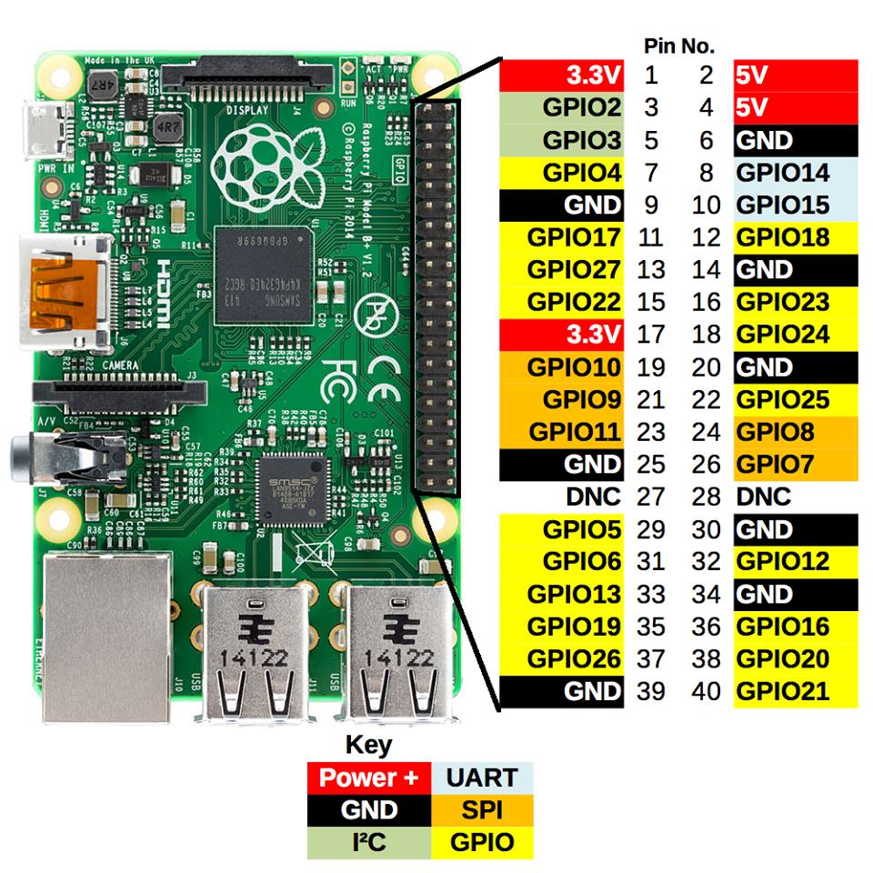

**Figure 4-1: Raspberry PI**

The Raspberry Pi 3 Model B is the third generation Raspberry Pi. This powerful credit-card sized single board computer can be used for many applications and supersedes the original Raspberry Pi Model B+ and Raspberry Pi 2 Model B. Whilst maintaining the popular board format the Raspberry Pi 3 Model B brings us a more powerful processer, 10x faster than the first generation Raspberry Pi. Additionally it adds wireless LAN & Bluetooth connectivity making it the ideal solution for powerful connected designs.

Connecting it to a computer with a USB cable or battery to get started simply.

|  |  |
| --- | --- |
| **Processor** | Broadcom BCM2837 SoC with a 1.2 GHz 64-bit quad-core ARM Cortex-A53 processor, with 512 KB shared L2 cache |
| **GPU** | Broadcom VideoCore IV @ 250 MHz  OpenGL ES 2.0  MPEG-2 and VC-1 |
| **Memory** | 1GB |
| **Operating System** | Boots from Micro SD card, running a version of the Raspbian operating system |
| **Network** | 10/100 Mbit/s Ethernet, 802.11n wireless, Bluetooth 4.1 |
| **Memory Card Slot** | Push/Pull micro SDIO |
| **USB 2.0 port** | 4 (via the on-board 5-port USB hub) |
| **GPIO Connector** | 40-pin 2.54 mm (100 mil) expansion header: 2x20 strip Providing 27 GPIO pins as well as +3.3 V, +5 V and GND supply lines |

**Table 4-1: Raspberry PI 3 Specifications**

### 4.1.2. Arduino Uno

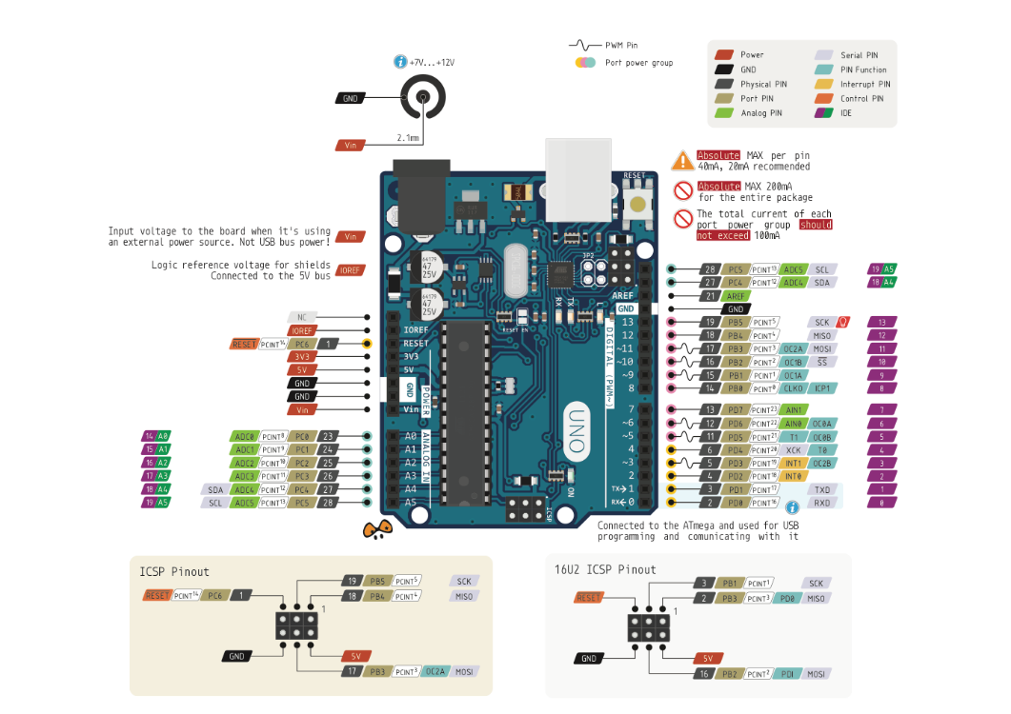

**Figure 4-2: Arduino Uno**

The Arduino Uno is a microcontroller board based on the ATmega328. It has 14 digital input/output pins (of which 6 can be used as PWM outputs), 6 analog inputs, a 16 MHz ceramic resonator, a USB connection, a power jack, an ICSP header, and a reset button. It contains everything needed to support the microcontroller; simply connect it to a computer with a USB cable or power it with a AC-to-DC adapter or battery to get started.

|  |  |
| --- | --- |
| **Microcontroller** | ATmega328 |
| **Architecture** | AVR |
| **Operating Voltage** | 5V |
| **Flash memory** | 32KB of which 0.5 KB used by Boot-loader |
| **SRAM** | 2KB |
| **Clock Speed** | 16 MHZ |
| **Analog I/O Pins** | 6 |
| **EEPROM** | 1 KB |
| **DC Current per I/O pins** | 40 mA on I/O pins; 50 mA on 3.3V pin |
| **Input Voltage** | 7 – 12 V |
| **Digital I/O pins** | 20 |
| **PWM Output** | 6 |
| **PCB Size** | 53.4 x 68.6 mm |
| **Weight** | 25g |

**Table 4-2: Arduino Uno specifications**

### 4.1.3. Arduino Wemos-D1R2

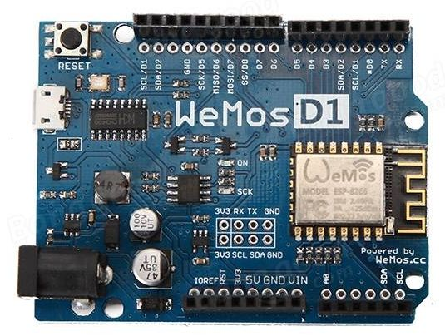

**Figure 4-3: Wemos-D1R2**

Wemos-D1R2 is an ESP8266-12 based WIFI enabled microprocessor unit on a Arduino-UNO footprint

|  |  |
| --- | --- |
| **Microcontroller** | ESP8266EX |
| **Operating Voltage** | 3.3V |
| **Input Voltage Range** | 9V to 24V |
| **Output** | 5V at 1A max |
| **Digital I/O pins** | 11 |
| **Analog input pins** | 1 |
| **Flash Memory** | 4MB |
| **Board Dimensions** | 68.6mm x 53.4mm |
| **Weight** | 25g |

**Table 4-3: Wemos-D1R2 specifications**

### 4.1.4. L298N – Motor module

The Motor Shield is based on the L298, which is a dual full-bridge driver designed to drive inductive loads such as relays, solenoids, DC and stepping motors. It lets us drive two DC motors, controlling the speed and direction of each one independently.

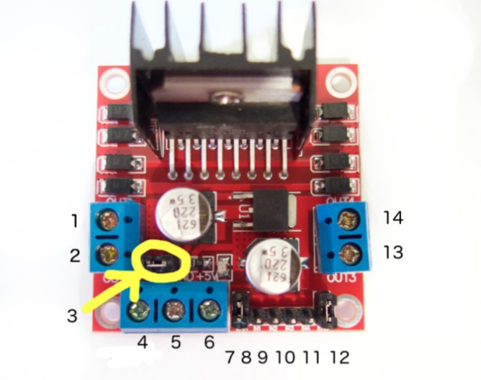

**Figure 4-4: L298N pin diagrams**

|  |  |
| --- | --- |
| **1** | DC motor 1 "+" or stepper motor A+ |
| **2** | DC motor 1 "-" or stepper motor A |
| **3** | 12V jumper - remove this if using a supply voltage greater than 12V DC. This enables power to the onboard 5V regulator |
| **4** | Connect your motor supply voltage here, maximum of 35V DC. Remove 12V jumper if >12V DC |
| **5** | GND |
| **6** | 5V output if 12V jumper in place, ideal for powering your Arduino |
| **7** | DC motor 1 enable jumper. Leave this in place when using a stepper motor. Connect to PWM output for DC motor speed control. |
| **8** | IN1 |
| **9** | IN2 |
| **10** | IN3 |
| **11** | IN4 |
| **12** | DC motor 2 enable jumper. Leave this in place when using a stepper motor. Connect to PWM output for DC motor speed control. |
| **13** | DC motor 2 "+" or stepper motor B+ |
| **14** | DC motor 2 "-" or stepper motor B |

**Table 4-4: L298N Pin-out**

* **Specification**
  + Operating Voltage: 4V ~ 35V
  + Motor controller L298N, Drives 2 DC motors or 1 stepper motor
  + Max current: 2A per channel or 4A max
  + Free running stop and break function
  + Summary Chip : ST L298N
  + Logic power supply : 5V
  + Max power : 25w
  + Weight : 35g
  + Size : 55mm x 60mm x 30mm
  + Storage temperature: -25oC ~ +135oC

### 4.1.5. Module XL6009

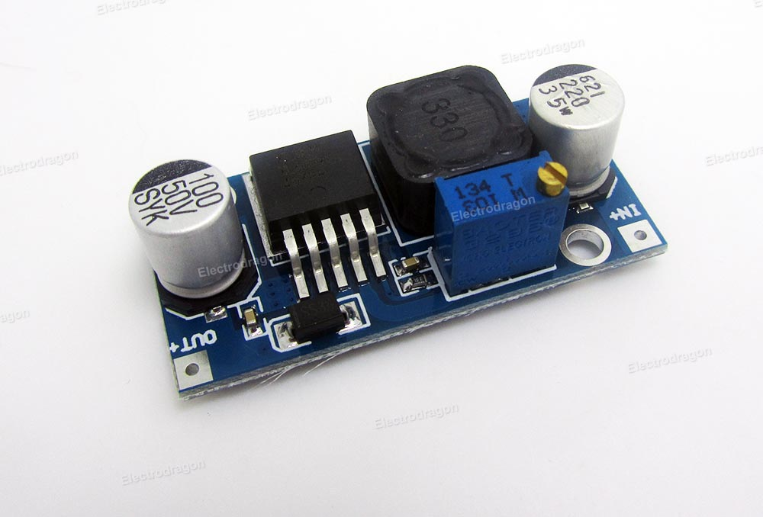

**Figure 4-5: Module XL6009E1**

The module uses the second generation of high-frequency switching technology XL6009E1 core chip performance than the first generation technology. XL6009 boost module has superior performance than LM2577 based modules.

|  |  |
| --- | --- |
| **Input voltage** | 3.2V ~ 32V |
| **Output Voltage** | 4V ~ 38V |
| **Modules Type** | Non-isolated step-up (Boost) |
| **Rectification** | Non-synchronous rectification |
| **Rated output current** | 3A |
| **Peak Output Current** | 4A |
| **Module size** | 43mm x 21mm x 14mm |
| **Input mode** | IN + input positive level, IN-input negative |
| **Conversion efficiency** | Up to 94% |

**Table 5-5: XL6009 specifications**

### 4.1.6. Charging circuit TP4056

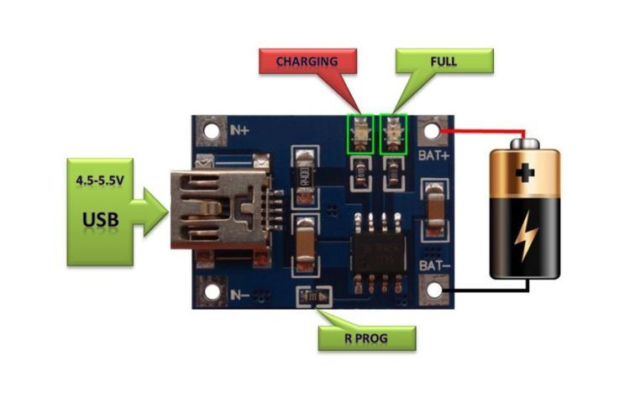

**Figure 4-6: Charging circuit**

This tiny module is perfect for charging single cell 3.7V 1Ah or higher LIPO cells such as 16550s that don’t have their own protection circuit. Based around the TP4056 charger IC and DW01 battery protection IC this module will offer 1A charge current then cut off when finished. Furthermore when the battery voltage drop below 2.4V the protection IC will switch the load off to protect the cell from running at too low of a voltage – and also protects again over voltage and reverse the polarity connection.

|  |  |
| --- | --- |
| **Input voltage** | 4.5 ~ 5.5V |
| **Full charge voltage** | 4.2V |
| **Operating ambient temperature range** | -10­­oC ~ +85oC |
| **Charging Current** | 1A (by default) |

**Table 4-6: Specifications**

### 4.1.7. Gear speed-reducer motor

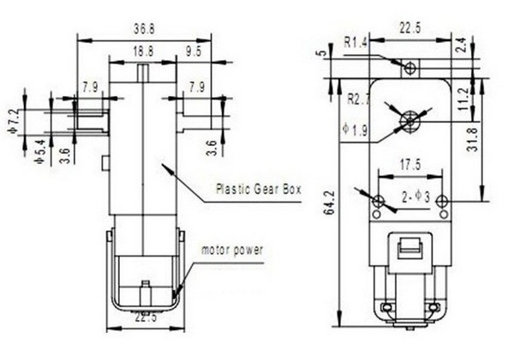

**Figure 4-7: Gear speed-reducer motor**

* **Specifications:**
  + **Input voltage : 3~9V**
  + **Input current : 150 ~ 200mA**
  + **Rate : 1/40**

|  |  |  |
| --- | --- | --- |
| **V** | **Current Consumption** | **Rounds per second** |
| 3V | **≤**200mA | 200 ± 10% |
| 6V | **≤**150mA | 90±10% |

**Table 4-7: Details**

### 4.1.8. Servo MG996R

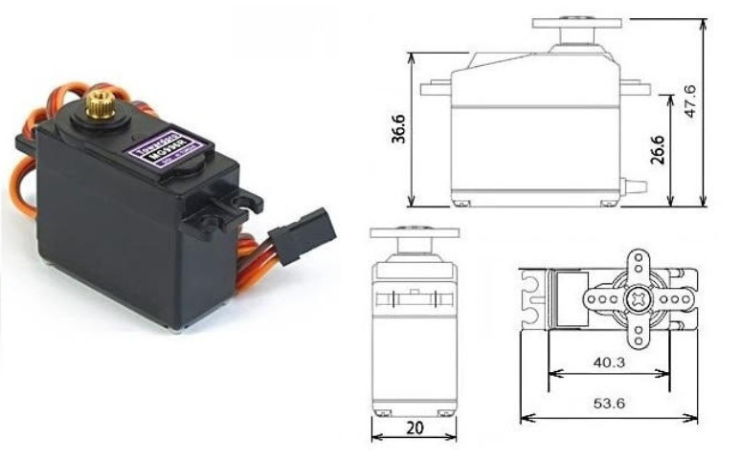

**Figure 4-8: MG9960R**

This High-Torque MG9660R digital servo features metal gearing resulting in extra high 10kg stalling torque in a tiny package.

|  |  |
| --- | --- |
| **Weight** | 55g |
| **Dimension** | 40.7 x 19.7 x 42.9mm approx. |
| **Stall torque** | 9.4 kg/cm (4.8V), 11 kg/cm (6V) |
| **Operating speed** | 0.17 sec/60o (4.8V), 0.14 sec/60o (6V) |
| **Operating Voltage** | 4.8V ~ 7.2V |
| **Running current** | 500mA ~ 900mA (6V) |
| **Stall current** | 2.5A (6V) |
| **Deal band width** | 5µ |
| **Temperature range** | 0oC ~ 55oC |

**Table 4-8: MG9960R specifications**

### 4.1.10. Camera Logitech C170

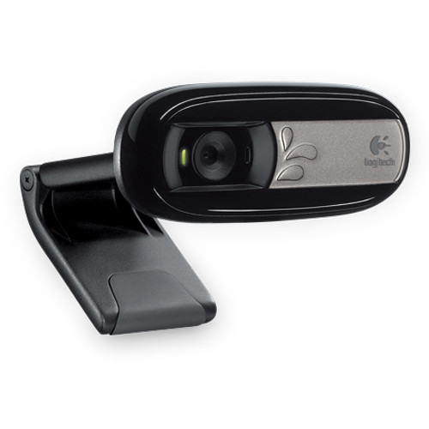

**Figure 4-10: Logitech C170**

* **Specifications**
  + Supports VGA 640 x 480 Video Calling
  + XVGA Video Capture Up to 1024 x 768
  + Take 5MP photos
  + Logitech Fluid Crystal Technology
  + Built-in microphone with Noise Reduction
  + Universal Clip for Laptops & Monitors
  + Hi-Speed USB 2.0 Certified

### 4.1.11. Module DC-DC Step-Down Voltage converter – MP1584

This DC/DC Step-Down voltage converter is based on MP1584, it converts input voltage between 4.5V and 28V into a smaller voltage between 0.8V and 18V, capable of driving a 3A load with excellent line and load regulation.

|  |  |
| --- | --- |
| **Input Voltage** | 4.5V ~ 28V |
| **Output Voltage** | 0.8V ~ 18V |
| **Continuous Output Current** | 3A Max |
| **Peek Output Current** | 4A |
| **Max. Efficiency** | 92% |
| **Switching Frequency** | 100kHz to 1.5MHZ |
| **Dimensions** | 22mm x 17mm x 4mm |

**Table 4-10: Specifications**

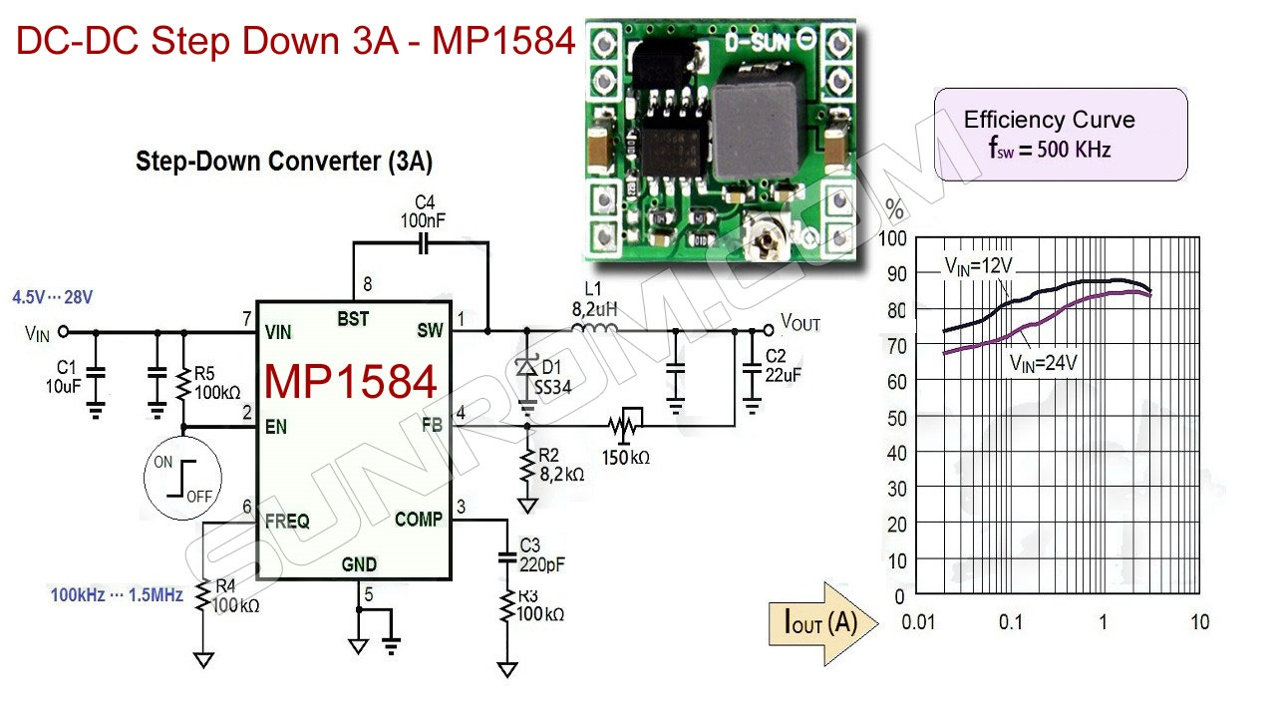

**Figure 4-11: DC-DC Step-Down Converter**

## 4.2. Software Study

### 4.2.1. Raspbian

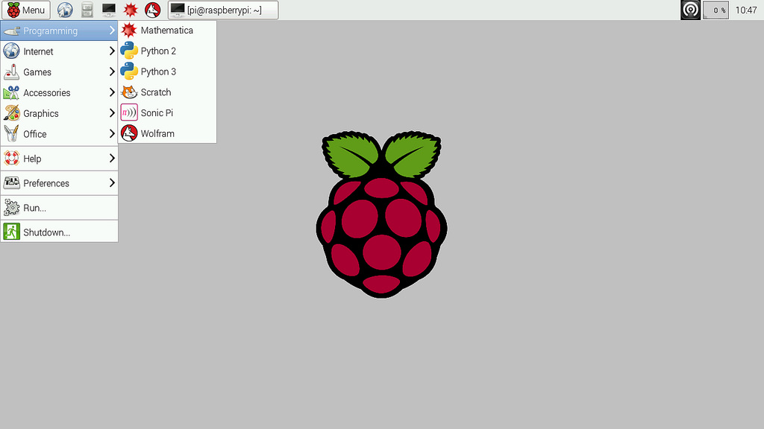

Raspbian has been the standard Raspberry Pi operating system, more commonly referred to as a “Distro”,  since the Pi arrived in 2012 and we have seen it grow over time into the capable Distro that we use today. Raspbian is a fork of the massively popular Debian distribution and it is jointly maintained by the Raspberry Pi Foundation and the community.

We choose this Operation system because: Being based on Debian, Raspbian comes with the APT (Advanced Packaging Tool) as it’s package manager, which is used to install software from the vast Raspbian repositories, but Raspbian also comes with raspi-config, a menu based tool that simplifies the act of managing Raspberry Pi configurations such as setting up an SSH, overclocking and enabling the official Raspberry Pi camera.

We now have a simplified and refined interface that groups applications and configuration tools into clearer categories. As Raspbian is the default distro for Raspberry Pi it is also the distro that sees the most improvement and innovations examples of this are the RPi.GPIO library that enables Python to talk to the GPIO (General Purpose Input Output) pins.

* **Feasibility of this choose:**
  + Easy-to-use interface
  + Large supportive community
  + Stability for taking first step with the Raspberry PI

### 4.2.2. Python



Python is an object-oriented, high-level, interpreted programming language with dynamic semantics. Its high-level built in data structures, combined with dynamic typing and dynamic binding, make it very attractive for Raspberry Pi Application Development, as well as for use as a scripting or glue language to connect existing components together. Python's simple, easy to learn syntax emphasizes readability and therefore reduces the cost of program maintenance. Python supports modules and packages, which encourages program modularity and code reuse. The Python interpreter and the extensive standard library are available in source or binary form without charge for all major platforms, and can be freely distributed.

* **Feasibility of this choose**
  + Easy to learn syntax
  + Reduces the cost of program maintenance
  + Encourages program modularity and code reuse
  + There is no compilation step, the edit-test-debug cycle is incredibly fast

# system design description (sdd)

## 5.1. Architecture design

|  |  |
| --- | --- |
|  | **Figure 5-1: Architecture design** |

## 5.2. Sequence diagram

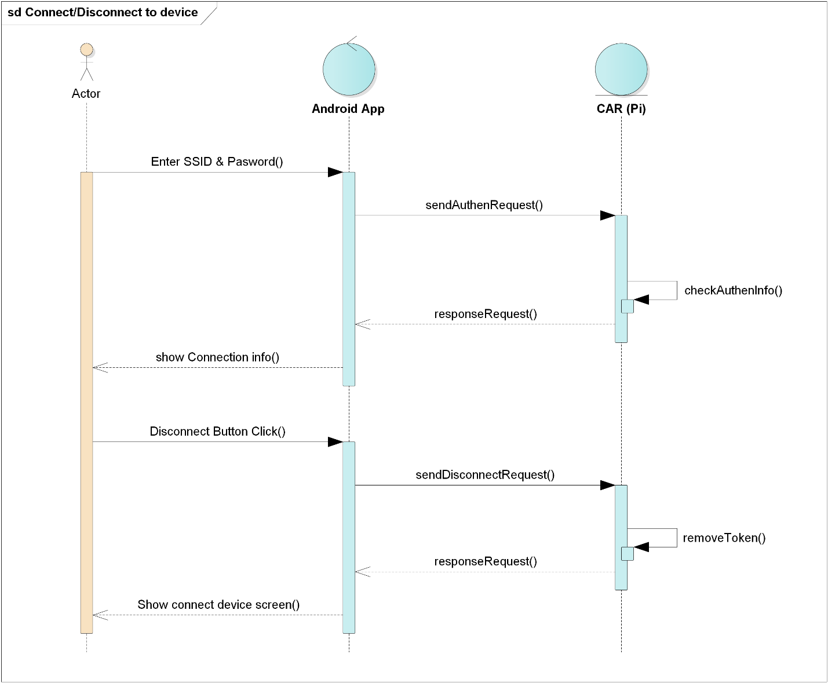

**Figure 5-1: Connect/Disconnect to device**

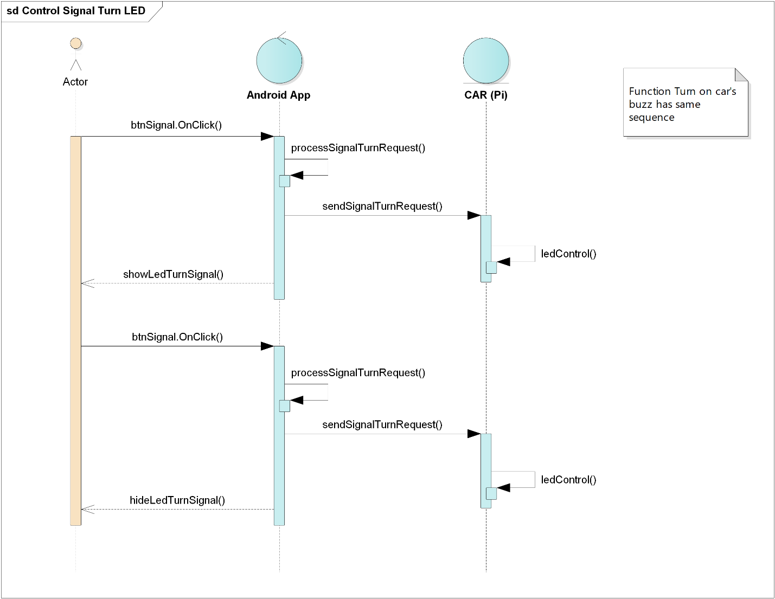

**Figure 5-2: Control signal turn LED**

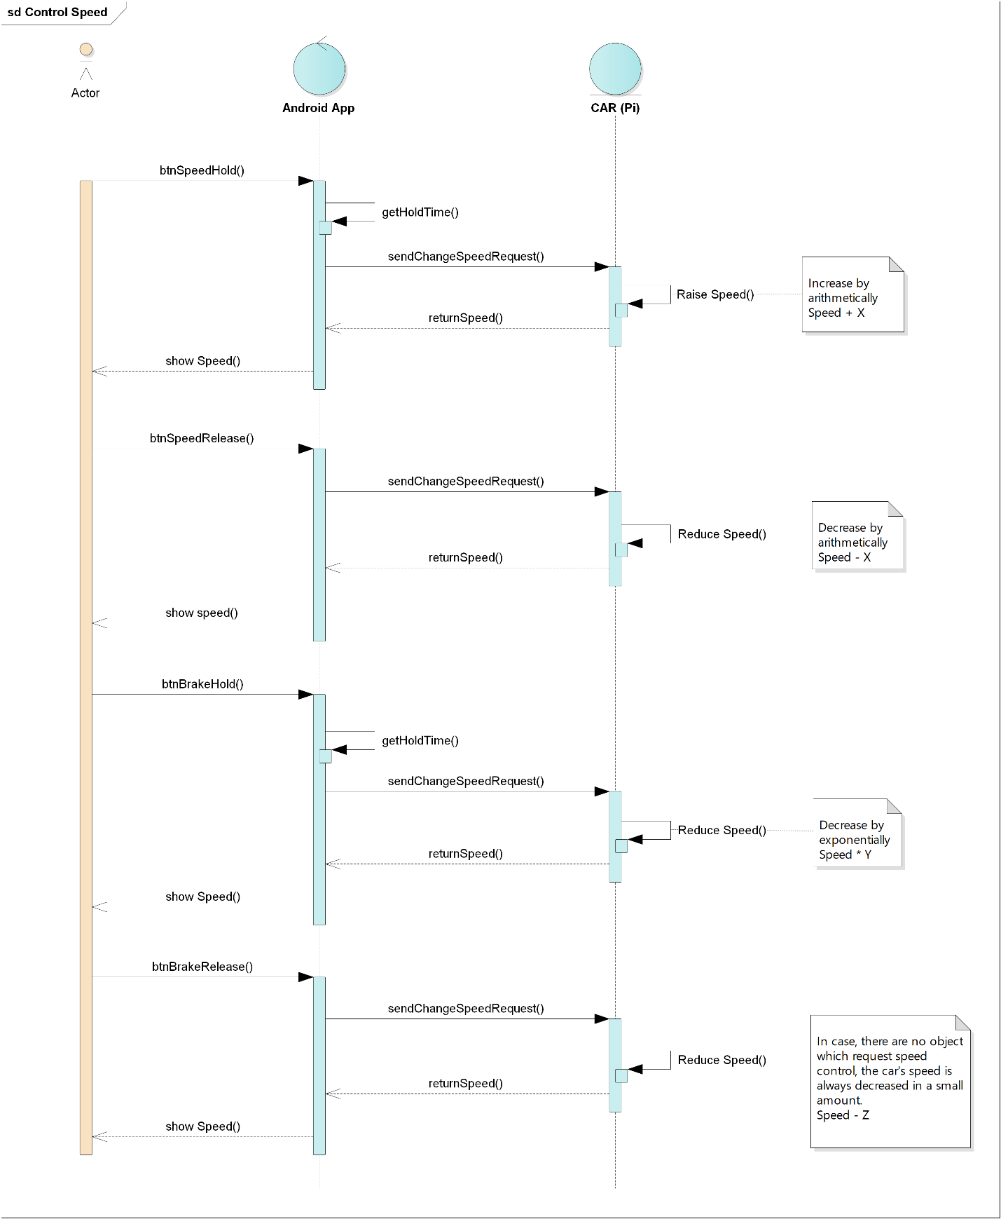

**Figure 5-3: Control Speed**

## 5.2. Flowchart

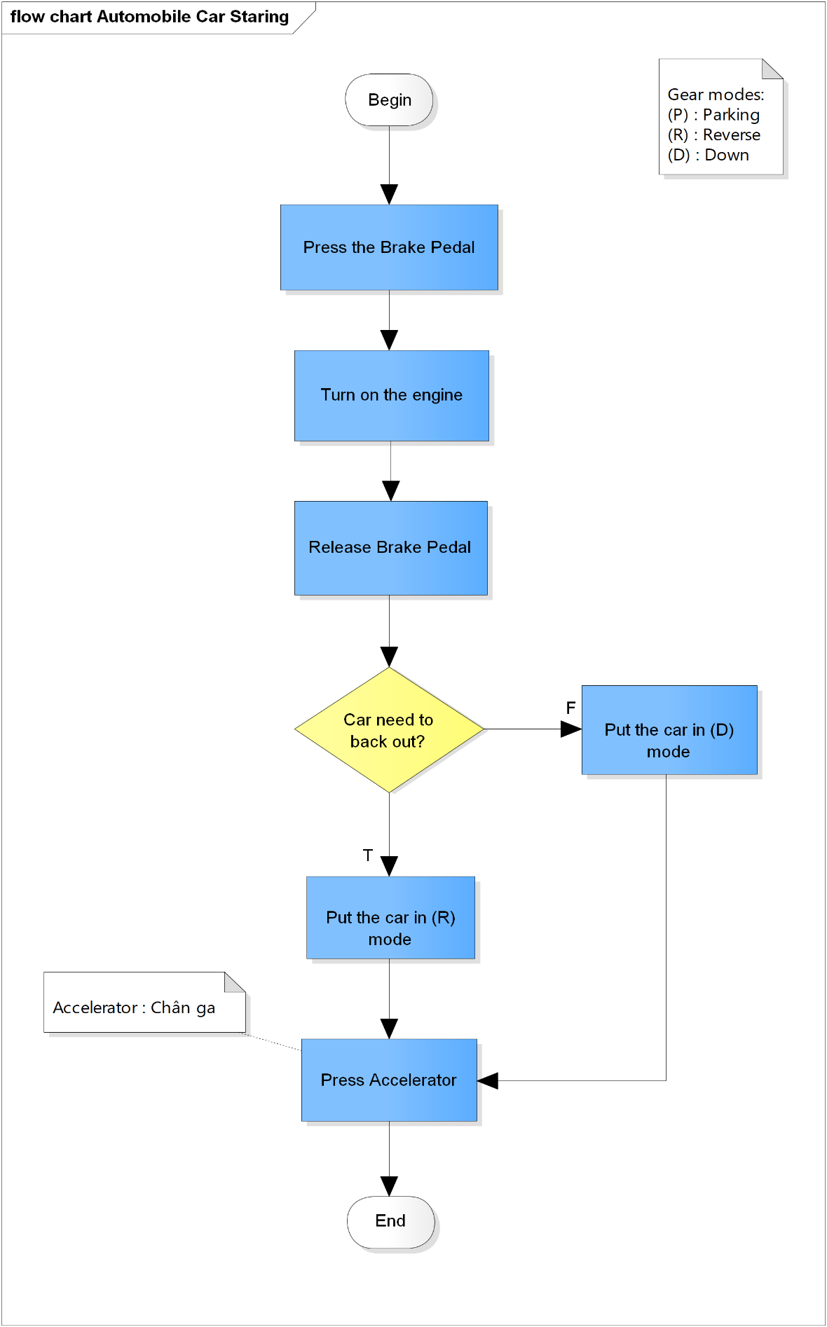

**Figure 5-4: Automobile car starting**

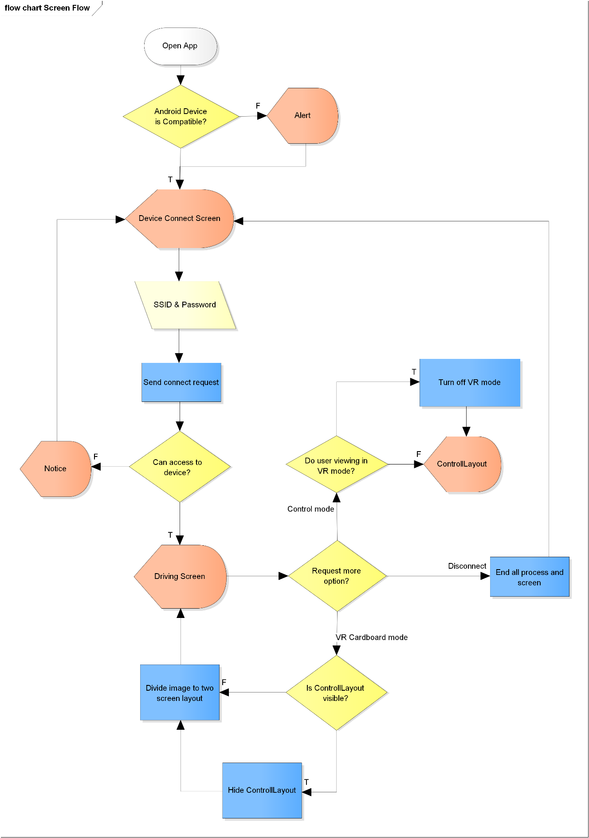

**Figure 5-5: Screen flow**

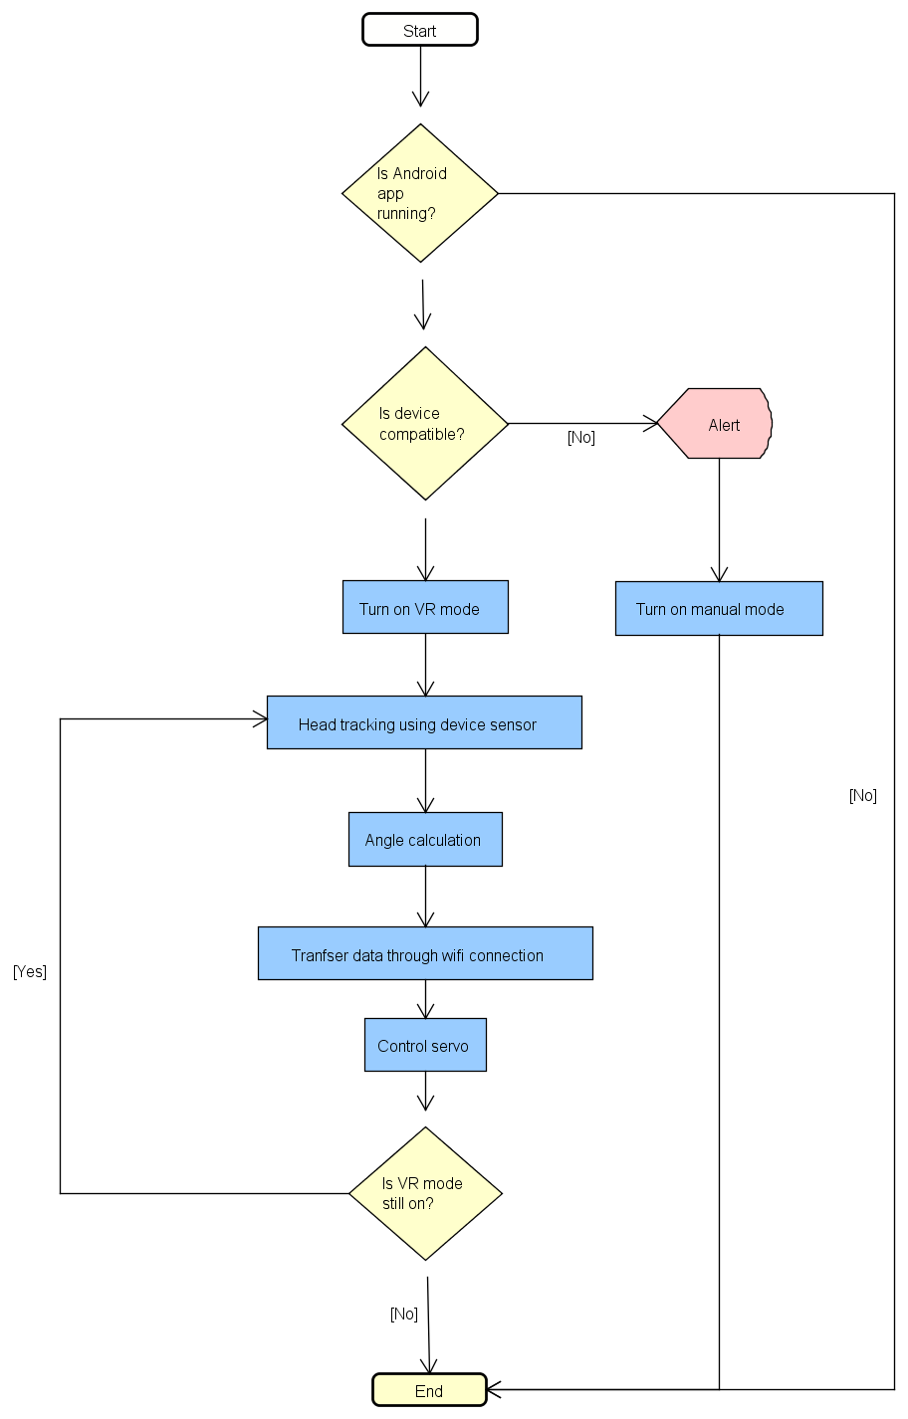

**Figure 5-6: Handling Sensor**

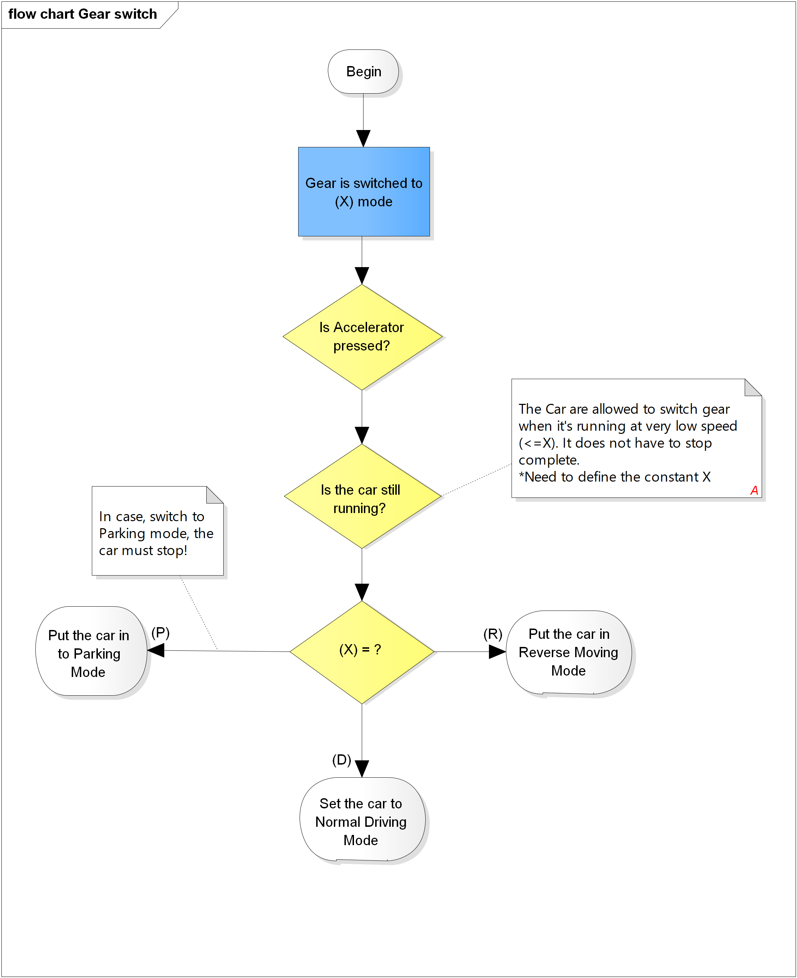

**Figure 5-7: Gear Switcher**

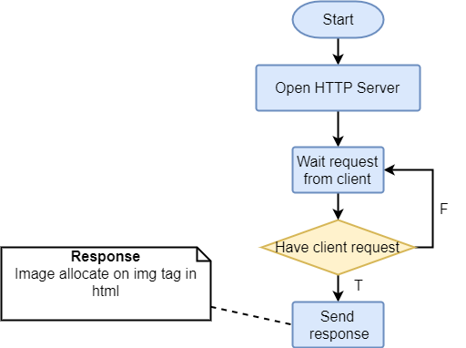

**Figure 5-8: Stream Video**

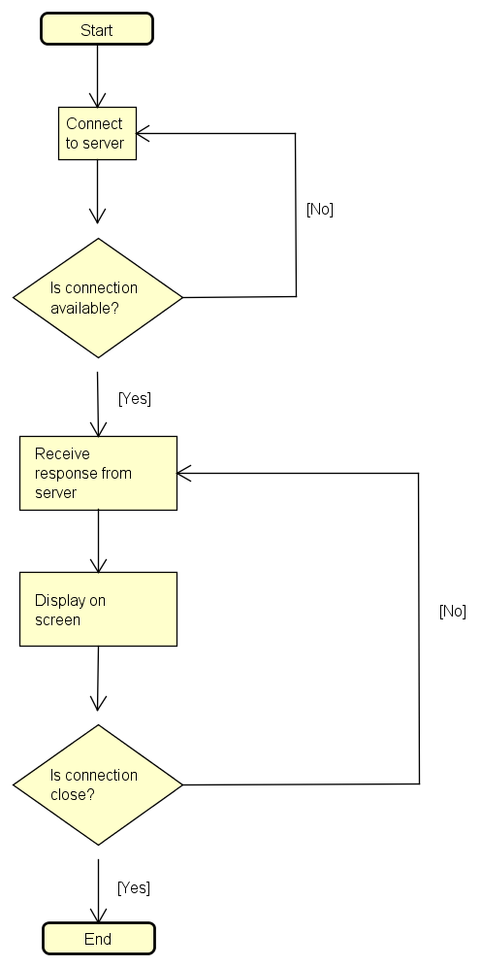

**Figure 5-9: Android Steam work flow**

# IMPLEMENTATION & Testing

## 6.1. Proposed system architecture

## 

**Figure 6-1: System architecture**

## 6.2. Analysis and selection of tools, devices

### 6.2.1. Motor controller

We used 2 motor combined with L9110s module to control car movement. The module will control 2 motor with customize speed.

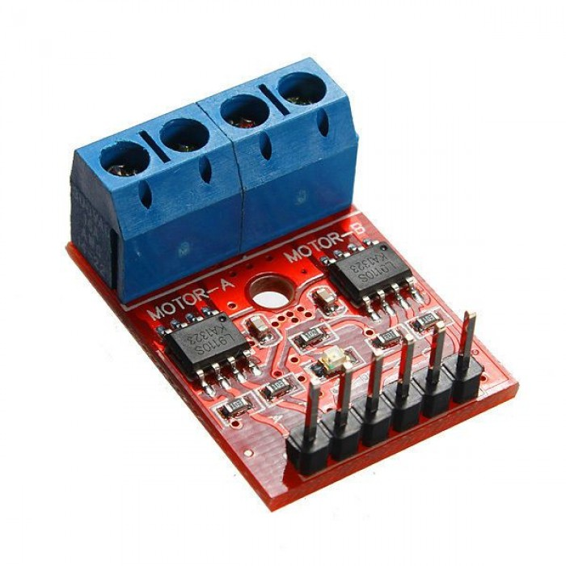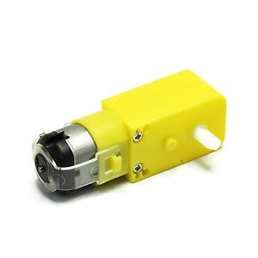

**Figure 6-2: Module L9110s Figure 6-3: Motor**

When the car go forward or backward, two motor will turned the same direction and speed.

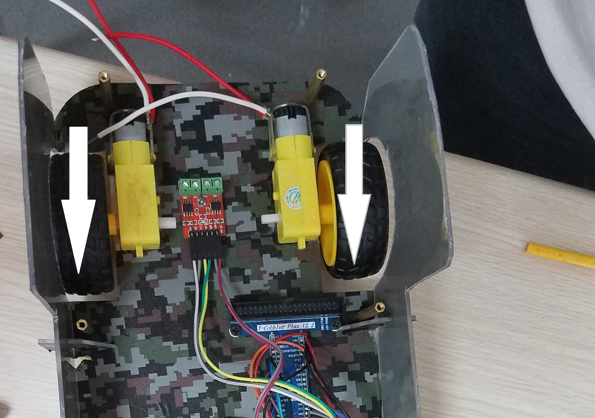

**Figure 6-4: Run forward**

### 6.2.2. Servo car

We used servo (MG996R) to control the car. When the car turn left (or right), the servo will turn into the opposite side (right or left).We also set the swivel angle of servo between 45 to 135

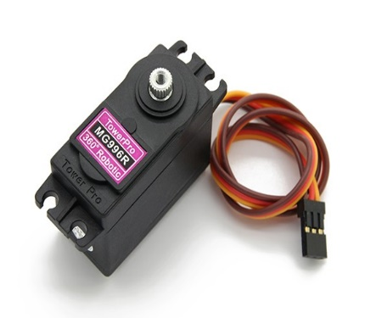

**Figure 6-5: Servo MG996R**

**Figure 6-6: Turn left**

### 6.2.3. Servo camera

We used servo (MG996R) to control the camera (Webcam Logitech C170). The servo combine with the Aluminum shelf to hold the camera. When driver turn Android device to left (or right), servo will turn in the same direction.

### 

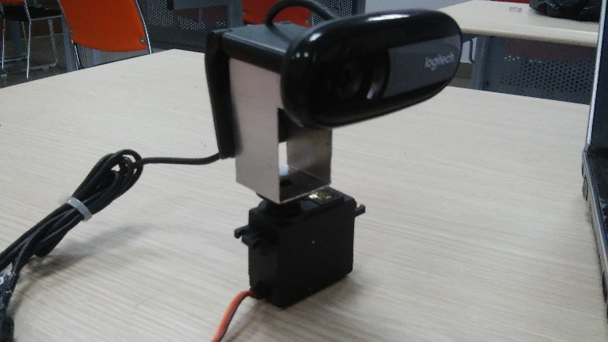

**Figure 6-7: camera servo**

### 6.2.4. Remote Controller

We use Arduino Uno to process data combine with WEMOS to transfer data to Raspberry server through WIFI; we also use mechanical parts of Panther-Lord (Car racing game control) to control the car in Remote Controller mode. The Remote include 3 parts:

* Steering: wheel , light and sound signal button
* Transmission : Gear lever, hand-break
* Pedals: throttle pedal, break-pedal

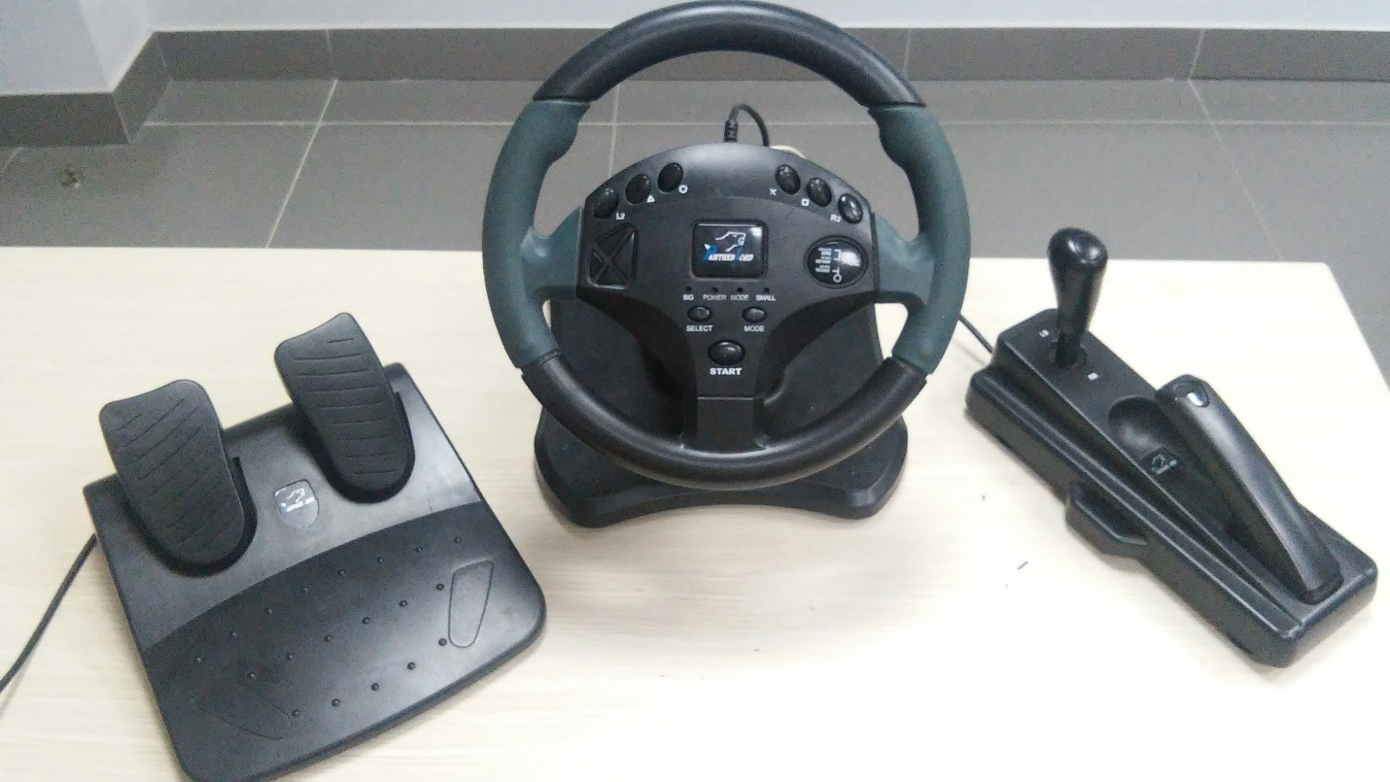

**Figure 6-8: Remote controller**

### 6.2.5. Supply power for car system

We use LGDB118650 pin cell, a rechargeable battery that can be use and recharge many time. We combine LGDB118650 with module XL6009 to convert voltage into 20V that suitable and powerful enough for the car system; and also use module DC-DC step-down converter MP1584 to convert voltage into 5V - suitable for Raspberry PI. Besides, we use Charging circuit TP4056 to help user recharge the pin cell in the easiest way.

**Figure 6-9: Power supply for car system**

## 6.3. Hardware design

### 6.3.1. Raspberry PI connector

|  |  |
| --- | --- |
|  | **Figure 6-10: Raspberry PI connector schematic** |

### 6.3.2. Remote controller

|  |  |
| --- | --- |
|  | **Figure 6-11: Remote Controller schematic** |

## 6.4. Software design

|  |  |
| --- | --- |
|  | **Figure 6-12: Software design** |

## 6.5. Mechanical Design

## 

|  |  |
| --- | --- |
|  | **Figure 6-13: Overview** |

|  |  |
| --- | --- |
|  | **Figure 6-14: Side view** |

|  |  |
| --- | --- |
|  | **Figure 6-15: Wire frame** |

## 6.6. Testing

### 6.6.1. Purpose

The primary purpose of this report is to detect software failures so that detects may

be discovered and correct to ensure that our project is thoroughly tested and resulting in a successful implementation project.

### 6.6.2. Test approach

* Unit testing
* Integration testing
* System testing
* Acceptance testing

### 6.6.3. Test environment:

|  |  |
| --- | --- |
| Resource | Name and type |
| Personal Laptop |  |
| Android smartphone |  |
| WIFI |  |
| Window 10 | Operating system |
| Android | Android 4.4, 5.1, 7.0 |
| Android Development tool | Android Studio |
| Arduino IDE | Arduino 1.8.1 |

### 6.6.4. Test Case

#### Software

|  |  |  |  |  |  |  |  |  |
| --- | --- | --- | --- | --- | --- | --- | --- | --- |
| No. | ID | Test case Description | Test Case Procedure | Expected Output | Inter-Test Case Dependence | Status | Date | Note |
| 1 | Android_1 | Open [Mini Explorer] main screen | Touch on [Mini Explorer] application icon | Open [Mini Explorer] main screen: screen is displayed with the following informations  -Text: Project name  - 1 connect button |  | Pass | 14/08/2017 |  |
| 2 | Android_2 | Showing [WIFI is turned off] dialog after press on [connect] button (If WIFI is turned off) | Touch on [Connect] button | Show alert dialog which contain a text: “WIFI is turned off” | [Mini Explorer] screen is displayed; WIFI of android device is off or not connect with Car WIFI | Pass | 14/08/2017 |  |
| 3 | Android_3 | Open [Controller] screen | Touch on [Connect] button | Open [Controller] screen: screen is displayed with the following informations  -1 [Disconnect] button  -5 control buttons  -2 buttons change speed  -1 [VR mode] button  -1 webview | [Mini Explorer] screen is displayed; WIFI of android device is on and connected with the Car WIFI | Pass | 14/08/2017 |  |
| 4 | Android_4 | Send control car data | Touch on [Gear switcher]/[pedal]/[break]/[light signal]/[sound signal]/[steering wheel] button | Send signal to car system and show message on Raspberry PI in order:  “Speed”:0, ”angle”:0, ”mode”:0, ”light”:0, ”buzzer”:0 | [Controller] screen is displayed;  WIFI of android device is on and connected with the Car WIFI | Pass | 14/08/2017 |  |
| 5 | Android_5 | Open [VR mode] screen | Touch on [VR mode] button | Open [VR mode] screen: screen is displayed with the following informations  -1 Webview that display Camera image info | [Controller] screen is displayed;  WIFI of android device is on and connected with the Car WIFI | Pass | 14/08/2017 |  |
| 6 | Android_6 | Send control camera module data | Turn android device to left or right | Send signal to car system and show message on Raspberry PI | [VR mode] screen is displayed;  WIFI of android device is on and connected with the Car WIFI | Pass | 14/08/2017 |  |

#### Hardware

|  |  |  |  |  |  |  |  |  |
| --- | --- | --- | --- | --- | --- | --- | --- | --- |
| No. | ID | Test Case Description | Test Case Procedure | Expected Output | Inter-Test Case Dependence | Status | Date | Note |
| 1 | Car_1 | Change run mode testing | Pull the [Gear switcher] | Raspberry receive correct message and change the car run mode | -[Controller] screen is displayed; WIFI of android device is on and connected with the Car WIFI | Pass | 14/08/2017 |  |
| 2 | Car_2 | Car turn left testing | Turn the [steering wheel] to left | Raspberry receive correct message and the car turn left | -[Controller] screen is displayed; WIFI of android device is on and connected with the Car WIFI | Pass | 14/08/2017 |  |
| 3 | Car_3 | Car turn right testing | Turn the [steering wheel] to left | Raspberry receive correct message and the car turn right | -[Controller] screen is displayed; WIFI of android device is on and connected with the Car WIFI | Pass | 14/08/2017 |  |
| 4 | Car_4 | Car increase speed testing | Push the [Pedal] | Raspberry receive correct message and the car increase speed | -[Controller] screen is displayed; WIFI of android device is on and connected with the Car WIFI | Pass | 14/10/2017 |  |
| 5 | Car_5 | Car decrease speed testing | Push the [Break] | Raspberry receive correct message and the car decrease speed | -[Controller] screen is displayed;  WIFI of android device is on and connected with the Car WIFI | Pass | 14/08/2017 |  |
| 6 | Car_6 | Sound signal testing | Press on the [Sound signal] | Raspberry receive correct message and turn on the sound signal | -[Controller] screen is displayed;  WIFI of android device is on and connected with the Car WIFI | Pass | 14/08/2017 |  |
| 7 | Car_7 | Turn on light signal testing | Press on the [Light signal left]/[Light signal right] | Raspberry receive correct message and turn on the light signal left/right | -[Controller] screen is displayed; WIFI of android device is on and connected with the Car WIFI | Pass | 14/08/2017 |  |
| 8 | Car_8 | Turn off light signal testing | Press on the [Light signal left]/[Light signal right] again | Raspberry receive correct message and turn off the light signal left/right | -[Controller] screen is displayed;  WIFI of android device is on and connected with the Car WIFI  -[Light signal left]/[Light signal right] has turned on | Pass | 14/08/2017 |  |
| 9 | Car_9 | Turn the [camera module] to left | Turn android device to left | Raspberry receive correct message and turn the [camera module] to left | -[Controller] screen is displayed;  WIFI of android device is on and connected with the Car WIFI  - Camera module has turned on | Pass | 14/08/2017 |  |
| 10 | Car_10 | Turn the [camera module] to right | Turn android device to right | Raspberry receive correct message and turn the [camera module] to right | -[Controller] screen is displayed; WIFI of android device is on and connected with the Car WIFI  - Camera module has turned on | Pass | 14/08/2017 |  |

# Results

## 7.1. Limitation of system

We find out the system may have these following limitations:

* Power supply for system is unstable
* Video Streaming delay
* Some JSON signal are missing when transfer from WEMOS to Server
* No casing for product

## 7.2. Solution for reducing limitations

To reduce some risk and limitation, we will implement a number of following activities:

* Use Step-up power module XL6009 to increase the power supply
* Reduce frame per second
* Increase response time when transfer JSON
* Manufacture casing for product

# System user’s Manual

## 8.1 Setting up hardware

Press the “power” button on car

**Figure 8-1: Press the “power” button**

Supply power for remote controller.

**Figure 8-2: supply power for Remote**

Remote Controller will be auto connect with the car system.

## 8.2 Android Application

The first, download and install the “Mini explorer” app on android device (Recommendation: Android 4.4+).

### 8.2.1 Connect WIFI

* Open WIFI setting on your smart phone
* Choose “RazzPi” WIFI
* Enter password (The WIFI SSID and password will be provided in user manual. Default: “123@123a” )
* Choose “Connect”

### Connect Car system

* Open “Mini explorer” app.
* Choose “Connect” button. After success, direct move to “Controller” screen.

**Figure 8-3: Open “Mini explorer” app**

**Figure 8-4: Choose “Connect” button on the main screen**

**Figure 8-6: Successful**

### Control car movement

* Pull the “gear switcher” down to change the run mode(Default mode: parking)
* Turn the “Steering wheel” to left (or right) that you want the car move in that direction.
* Push the “Pedal” button to increase the car speed
* Push the “Break” button to decrease the car speed

**Figure 8-7: Controller Screen**

**Figure 8-8: Run mode**

### VR mode

Push the “VR” button to enter the VR mode, after that put your android device into the VR (Virtual reality) headsets. Now, your android device will only display the camera view and you can control your car by using the “remote controller”. You can also turn the camera to left (or right) by turn your head to the direction that you want.

**Figure 8-9: VR mode**

**Figure 8-10: Remote controller**

# References

* <https://developer.android.com>/bophoh
* <https://arduino.vn>
* <http://linhkienhanoi.com>
* <https://python.org>